Applying the Buy America Preference (BAP) to HUD Funded Projects: A Detailed Guide
Revised June 23, 2025

This guide is designed to assist the City of Duluth’s subrecipients in complying with the “Buy America Preference” (BAP) imposed by the Build America, Buy America Act (BABA) enacted under Division G, Title IX of the Infrastructure Investment and Jobs Act (IIJA, Pub. L. No. 117-58) signed into law on November 15, 2021. This guide is not exhaustive; it is designed to summarize requirements for programs most often funded by the City of Duluth Entitlement funds.

First, determine whether the BAP applies to your project:
- Is it an infrastructure project (note the definition applies very broadly, beyond what you may typically think of as infrastructure)?
  - Infrastructure: includes, at a minimum, the structures, facilities, and equipment for roads, highways, and bridges; public transportation; intercity passenger railroads; water systems, including drinking water and wastewater systems; and buildings and real property.
  - Infrastructure Project: Includes construction, alteration, maintenance and repair of:
    - Buildings and real property
    - Utilities
    - Water systems
    - Broadband infrastructure
- Is the project funded in whole or in part by federal funds obligated on or after 11/15/2021, including:
  - Community Development Block Grant (CDBG)
  - HOME Investments and Partnerships (HOME)
  - Emergency Solutions Grant (ESG)
  - Housing Trust Fund (HTF)

If you answered “Yes” to questions 1 and 2, your project is likely subject to the BAP, unless it meets requirements for an applicable waiver. Review the list of five general waivers below, and if more than one applies, select the one that is most applicable:

- Small Grants Waiver: Applies to infrastructure projects whose total cost (from all funding sources) is equal to or less than $250,000.
- De Minimis Waiver: May apply to a small portion of an infrastructure project, meaning a cumulative total of no more than five percent of the total cost of the iron, steel, manufactured products, and construction materials used in and incorporated into the infrastructure project, up to a maximum of $1 million.
- Exigent Circumstances Waiver: Applies when there is an urgent need to complete an infrastructure project because of a threat to life, safety, or property or residents and the community.
- Tribal Recipients Waiver: The BAP is waived for Tribal recipients of federal funds.
- Public Interest Phased Implementation Waiver: Use Figure 1.1 chart to determine whether your project needs to report on every category of materials, or only certain categories, depending on your grant and fund year (the program fund year, not the calendar year).

Once you’ve determined the BAP applies to your project, use the table below to understand which materials must be certified. If the BAP does not apply, please complete Form 2501 with your determinations and return to duluthcommdev@duluthmn.gov.

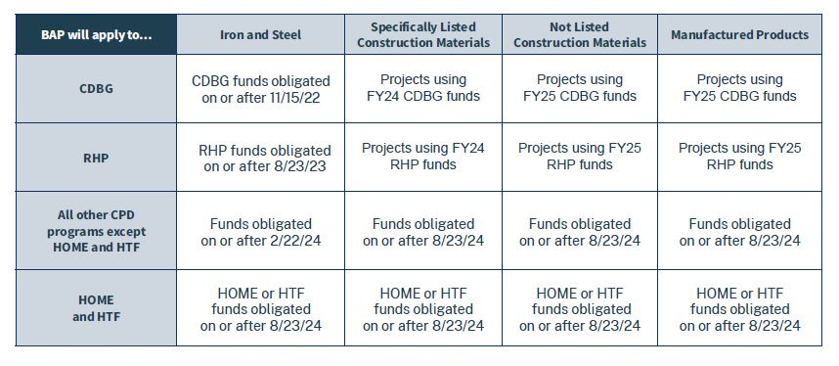
Figure 1.1
Please note: A Buy America Preference, if applicable, will apply to both the federal and non-federal funds used in an infrastructure project.

Include the following language in all bid documents, subawards, and contracts:
“Pursuant to the Build America, Buy America Act (BABA), enacted as part of the Infrastructure Investment and Jobs Act (IIJA). Pub. L. 117-58, 41 U.S.C. § 8301 note, the Federal Financial Assistance used to fund this infrastructure project is required to apply a domestic content procurement preference (the “Buy America Preference” or “BAP”) for all construction, alteration, maintenance, or repair of infrastructure, including buildings and real property, unless application of the BAP has been waived by HUD. Additional details on fulfilling the BABA requirements can be found at https://www.hud.gov/baba.

All, or some, of these categories may need to be reported, depending on your project’s federal grant year (see Figure 1.1). Once you’ve determined which products are subject to the BAP, ask your contractor to compile a list of those materials to be used in your project.

- Iron or steel products: articles, materials, or supplies that consist wholly or predominantly of iron or steel or a combination of both.
- Predominantly of iron or steel or a combination of both means that the cost of the iron and steel content exceeds 50 percent of the total cost of all its components. The cost of iron and steel is the cost of the iron or steel mill products (such as bar, billet, slab, wire, plate, or sheet), castings, or forgings utilized in the manufacture of the product and a good faith estimate of the cost of iron or steel components.

- Construction Materials: articles, materials, or supplies that consist of only one of the items listed in paragraph (a) of this definition. To the extent one of the items listed in paragraph (a) contains as inputs other items listed in paragraph (a), it is nonetheless a construction material. Minor additions of articles, materials, supplies or binding agents to a construction material do not change the categorization of the construction material.
- The listed items are:
    - Non-ferrous metals;
    - Plastic and polymer-based products (including polyvinylchloride, composite building materials, and polymers used in fiber optic cables);
    - Glass (including optic glass);
    - Fiber optic cable (including drop cable);
    - Optical fiber;
    - Lumber;
    - Engineered wood, and
    - Drywall.

For Phased Implementation, “Construction materials” are broken down in two categories:
- Specifically listed construction materials for HUD programs includes:
  - non-ferrous metals;
  - lumber;
  - composite building materials; and
  - plastic and polymer-based pipe and tube.

- Not Listed Construction Materials refers to the category of construction materials that are subject to the BAP, but not included in HUD’s specifically listed construction materials, as defined in the Phased Implementation Waiver.
  - plastic and polymer-based products other than composite building materials or plastic and polymer-based pipe or tube;
  - glass (including optic glass); and
  - drywall.
- Manufactured Products is defined in 2 CFR 184.3 and means articles, materials, or supplies that have been:
  - Processed into a specific form and shape; or
  - Combined with other articles, materials, or supplies to create a product with different properties than the individual articles, materials, or supplies.
  - If an item is classified as an iron or steel product, a construction material, or a section 70917(c) material under 2 CFR 184.4(e) and the definitions set forth in this section, then it is not a manufactured product. However, an article, material, or supply classified as a manufactured product under 2 CFR 184.4(e) and paragraph (1) of this definition may include components that are construction materials, iron or steel products, or section 70917(c) materials.

Produced in the United States is defined in 2 CFR 184.3 as:
      - In the case of iron or steel products, all manufacturing processes, from the initial melting stage through the application of coatings, occurred in the United States.
      - In the case of manufactured products: The product was manufactured in the United States; and
  - The cost of components of the manufactured product that are mined, produced, or manufactured in the United States is greater than 55 percent of the total cost of all components of the manufactured product, unless another standard that meets or exceeds this standard has been established under applicable law or regulation for determining the minimum amount of domestic content of the manufactured product. See 2 CFR 184.2(a). The costs of components of a manufactured product are determined according to 2 CFR 184.5.
      - In the case of construction materials, all manufacturing processes for the construction material occurred in the United States. See 2 CFR 184.6 for more information on the meaning of “all manufacturing processes” for specific construction materials.

Manufacturer Certification
Your chosen manufacturer(s) must provide a letter certifying the products sourced from them comply with the BAP. The letter must include the following:
- The list of materials subject to the BAP that they produce;
- A statement certifying the specific manufacturing and production requirements per the BABA are met;
- The company letterhead; and
- Signature of an authorized manufacturer employee.

City staff recommend early and frequent coordination with both your contractor(s) and Community Development staff. This can include early review of bid documents, pre-bid meetings to identify any covered materials that may be a challenge to source domestically, or any other coordination needed by you or your contractor as your project proceeds.

It is the subrecipients’ responsibility to track BABA requirements and provide all certifications. Any certifications not reported to the City of Duluth prior to construction must be sent as soon as possible during the construction process.

