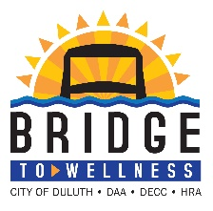**PLANT-BASED EATING & WHAT IT CAN DO FOR YOU**

Join us for a FREE lunch and learn where Dr. Tabor will share plant-based eating and it’s health-outcomes, and how it can reverse the progression of chronic diseases like heart disease and diabetes.

**WHO**: **All employees** (City, DECC, HRA, DAA) are welcome!

**WHAT**: FREE Lunch and Learn (bring your own lunch)

**WHEN:** Wednesday, February 5, 2020 at 12:00pm

**WHERE:** City Hall Conference Room 330

**FREE:** Sign in for Wellness Points!

Please RSVP with Wellness Coordinator, Angel Hohenstein, at 218-730-5201 or email [ahohenstein@duluthmn.gov](mailto:ahohenstein@duluthmn.gov) so we know how many to expect.