

The arrival of the fall and winter months signals many things, including the beginning of flu season. According to the Centers for Disease Control and Prevention (CDC), flu activity peaks between December and February.

**Flu Symptoms**

Seasonal influenza can cause serious complications for people of any age, but children and the elderly are more vulnerable. The flu is most often associated with the sudden onset of fever, headache, fatigue, muscle aches, congestion, cough and sore throat. Most people recover within a few days to less than two weeks. Occasionally, complications such as pneumonia, bronchitis or other infections can occur.

**Flu Prevention**

The flu vaccine is your best chance of preventing the illness. Currently, the CDC recommends that anyone over 6 months of age receive an annual flu vaccine.

While there are many different types of flu viruses, the vaccine protects you against the viruses that experts believe will be most common that year.

In addition to getting your annual vaccine, here are some other tips to stay healthy this season:

* Avoid close contact with people who are sick, and stay away from others when you feel under the weather.
* Wash your hands often using soap and warm water to protect against germs.
* Get plenty of sleep, stay physically active and drink plenty of water to keep your immune system strong.
* Manage your stress and eat a nutritious diet rich in healthy grains, fruits, vegetables and fiber.

It’s That Time of the Year Again:

Flu Season Is Here

Provided by City of Duluth JPE

**November 2019**

This article is intended for informational purposes only and is not intended to be exhaustive, nor should any discussion or opinions be construed as professional advice. Readers should contact a health professional for appropriate advice. © 2019 Zywave, Inc. All rights reserved.

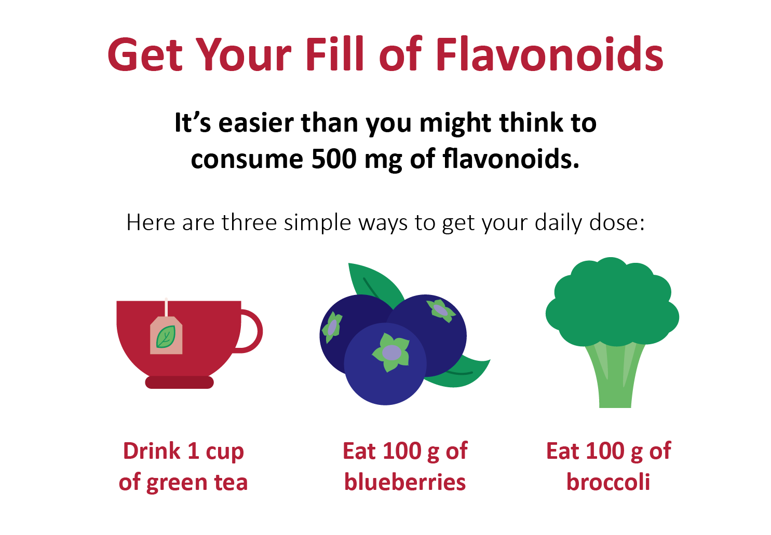

**Autumn Vegetable Succotash**

¼ cup olive oil

1 cup onion (diced)

2 garlic cloves (finely chopped)

2 cups red bell pepper (chopped)

2 cups zucchini (diced)

2 cups yellow summer squash (diced)

3 cups lima beans (frozen)

3 cups corn (frozen)

2 tsp. dried sage

**Preparations**

1. In a skillet over medium-high heat, add oil.
2. Add onion and cook until translucent.
3. Add garlic, bell peppers, zucchini, squash, lima beans and corn. Season as desired.
4. Cook, stirring, until vegetables are tender (about 10 minutes). Stir in sage and serve.

Makes: 8 servings

**Nutritional Information (per serving)**

|  |  |
| --- | --- |
| Total Calories | 203 |
| Total Fat | 8 g |
| Protein | 7 g |
| Carbohydrates | 30 g |
| Dietary Fiber | 7 g |
| Saturated Fat | 1 g |
| Sodium | 43 mg |
| Total Sugars | 6 g |

Source: USDA

An Apple a Day May Help Keep the Doctor Away

You’ve heard the saying, but it turns out there’s truth in the statement. Apples are rich in flavonoids, which can help you reduce your risk of disease, according to a recent [study](https://www.nature.com/articles/s41467-019-11622-x) published in the Nature Communications journal.

Flavonoids are a diverse group of naturally occurring plant chemicals that pack a powerful punch of antioxidants and anti-inflammation properties. There are a wide variety of foods that are considered flavonoids, including strawberries, blueberries, green and black tea, onions, kale and celery.

The research found that those who consumed at least 500 milligrams (mg) of flavonoids per day had the lowest risk of developing cancer or heart disease. Additionally, the health-boosting effects of flavonoids appeared to be strongest for smokers and those who drank more than two alcoholic beverages per day.

The study’s authors note that flavonoid consumption shouldn’t be used as a quick fix to remedy poor habits, but that when combined with living an overall healthy lifestyle, it could be useful for keeping disease at bay.

This Popular Beverage Is Linked to Earlier Death

Yet another study has linked drinking soda to negative health effects. The European study, which researched the health of participants for an average of 16 years, found that drinking more than two sodas per day is linked to a risk of earlier death.

The researchers explained that the sugar in soda—regardless of whether the soda is diet or regular—can lead to obesity and can affect how your body uses insulin. Both of these conditions can shorten your life. In addition to this study’s findings, soda consumption has also been linked to an increased risk for cancer and heart disease.

To protect your health, try opting for water as your beverage choice whenever possible. For more information about the health risks of soda, please consult your doctor.