

A recent study published in Scientific Reports revealed that spending 120 minutes a week outdoors can improve your health and psychological well-being. Remember, well-being refers to feeling good and living both safely and healthily. And, the concept of well-being can have implications on your overall quality of life, health and happiness.

**What are the benefits of spending time outside?**

Exercising in nature has been proven to improve one’s mental and physical health. Being outside also helps to promote higher vitamin D levels, a vitamin the body makes when skin is directly exposed to the sun. Many people are deficient in vitamin D, so exercising outside can be a great way to correct that.

In addition, outdoor activity can help you maintain a healthy weight, boost immunity and lower stress. Exercising outside can feel less routine than working out in a gym.

**What counts as spending time outdoors?**

Visiting town parks, greenspaces, woodlands and beaches all count as spending time outdoors. Here are two simple activities that you can do outside:

1. Walking or hiking—Hiking and walking have been proven to improve heart health and can help you maintain a healthy waistline.
2. Riding your bike—Riding a bike helps improve balance and endurance, and it’s an exercise that’s easy on your joints.

**Be Prepared**

Before you head outside and start improving your health today, you need to make sure that you’re properly prepared. This means that you should pack water, first-aid supplies, sun protection and, if you’re spending a significant amount of time outside, a healthy snack to help you refuel.

Getting Outside May Be the Key to Boosting Your Physical and Psychological Well-being

Provided by City of Duluth JPE

**September 2019**

This article is intended for informational purposes only and is not intended to be exhaustive, nor should any discussion or opinions be construed as professional advice. Readers should contact a health professional for appropriate advice. © 2019 Zywave, Inc. All rights reserved.

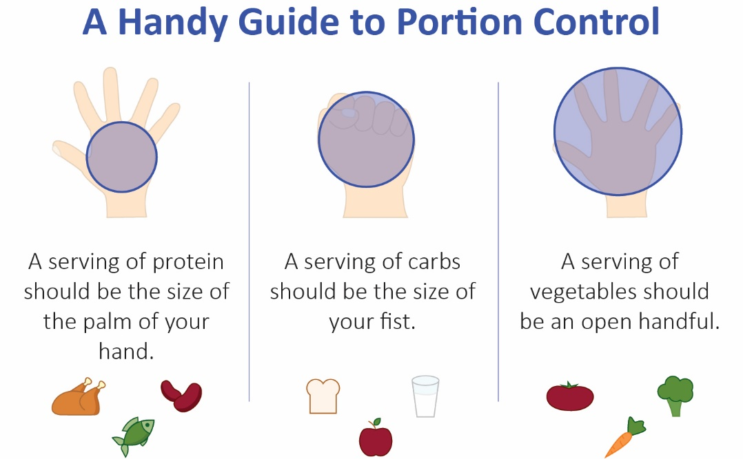

Making Smart Food Choices at a Restaurant

Eating healthy doesn’t always mean sacrificing your favorite meals. Although it may not seem like it, you can still stay on track with your diet when enjoying a meal out with friends and family.

Since restaurants—especially fast food chains—tend to use more fat, salt and sugar than home-cooked meals, you just need to be smart about what you order from the menu. To make it simple, here are some things to keep in mind next time you’re eating out:

* Avoid fried and carb-heavy options, like fried chicken or macaroni and cheese.
* Watch your portion size, as many restaurants give you more than one serving.
* Be mindful of your beverage choice, since there are many hidden calories in sugary sodas and alcoholic drinks.

An Increasing Number of Americans Are Making the Switch to Veganism

While veganism isn’t a new concept, it has grown in popularity over the past few years. In fact, according to GlobalData, the number of vegans in the United States grew from 1% to 6% between 2014 and 2017.

Those who are vegan do not eat anything containing animal products (such as dairy and eggs), and prefer not to use products made of fur, leather, wool or down feathers. People who choose to follow a vegan diet do so for various reasons, including environmental, ethical or health reasons.

Making the switch from animal-based products is something you can do on your own. Making the switch in your diet, though, is a more involved process. Every person is different. That’s why it’s important to discuss your desire to become a vegan with your doctor before you change your diet.

**Potato and Ham Skillet With Eggs**

2 potatoes (peeled and diced)

2 Tbsp. vegetable oil

2 onions (small, chopped)

1 green pepper (chopped)

6 eggs (beaten)

¼ tsp. black pepper

6 ounces frozen ham (thawed and chopped, about 1 cup)

1 cup reduced-fat cheddar cheese (shredded)

**Preparations**

1. In a medium-size skillet, cook potatoes in oil over medium heat until just soft, about 5 to 10 minutes.
2. Stir in onion, green peppers and ham, and cook 5 minutes.
3. Pour eggs and black pepper over potato mixture in pan, and sprinkle with cheese.
4. Cook for 5 minutes, stirring occasionally, or until eggs are firm and cheese is melted.

Makes: 6 servings

**Nutritional Information (per serving)**

|  |  |
| --- | --- |
| Total Calories | 290 |
| Total Fat | 15 g |
| Protein | 19 g |
| Carbohydrates | 19 g |
| Dietary Fiber | 3 g |
| Saturated Fat | 5 g |
| Sodium | 540 mg |
| Total Sugars | 4 g |

Source: USDA