STEP BY STEP GUIDE TO ONLINE TRACKING SYSTEM FOR WELLBEING PROGRAM
Step 1: Go to the Bridge (either “internally” or from the City of Duluth website as pictured below)
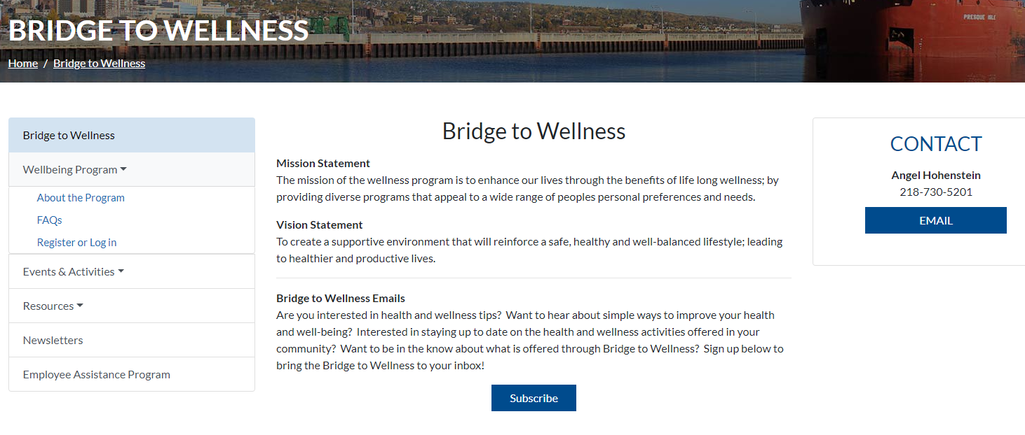
From the City of Duluth website, you will click on the “Register or Log in” tab under “Wellbeing Program” as listed on the left side of the page.

Step 2: Click on the green “Register Now!” button if using the City of Duluth Bridge page. If you are using the “internal” Bridge (picture below) you will click on the underlined “Register Now!” link
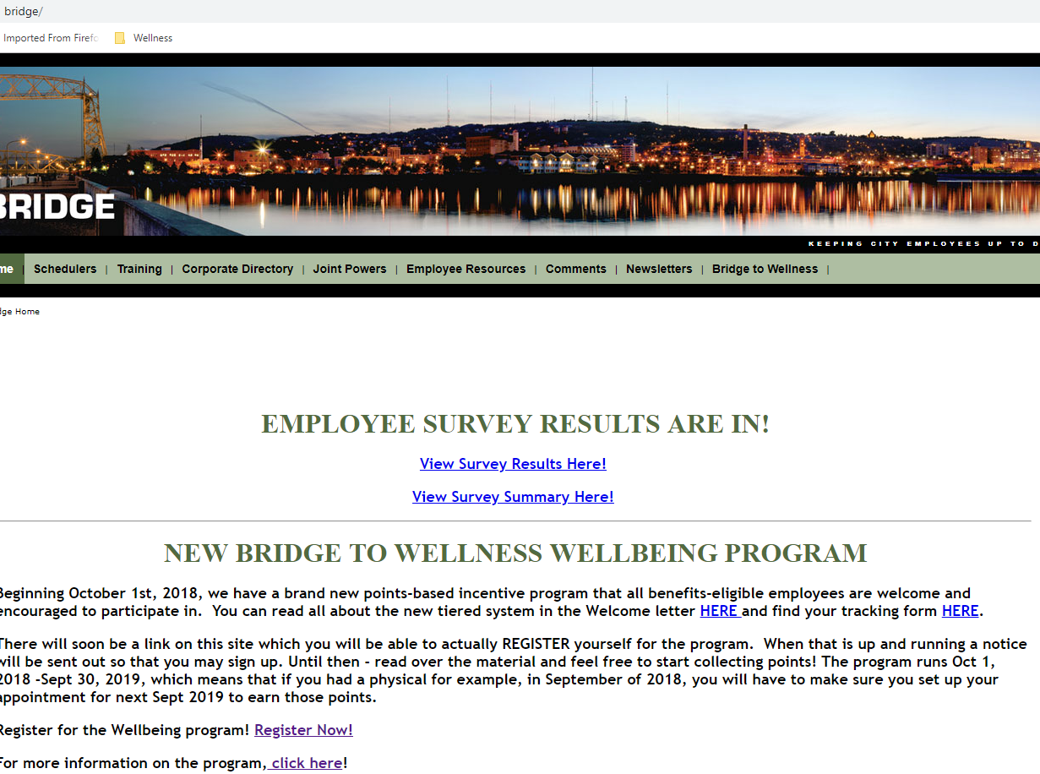
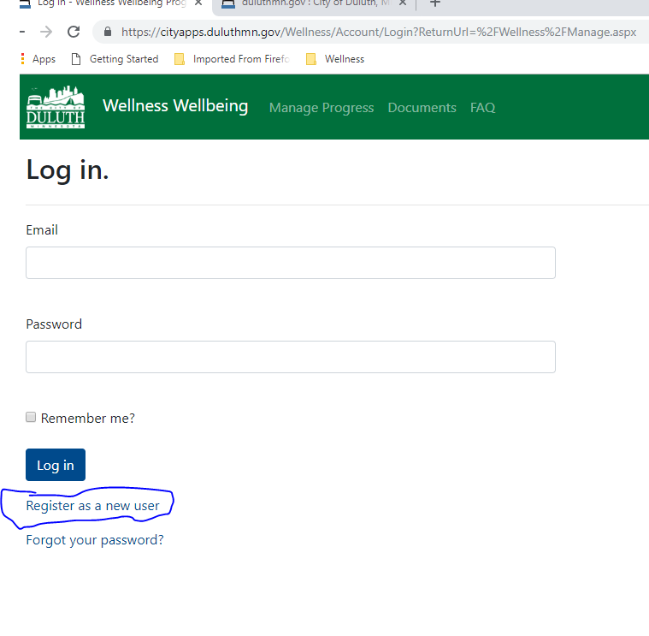
Step 3: Once you have clicked “Register Now!” it will bring you to the below page, where you will click on “Register as a new user” (underneath email and password)

Step 4: As a new user, you will need to provide First Name (as it appears on your paycheck); Last Name; Organization (select from Airport Authority, City of Duluth, DECC or HRA); Employee Number - which is found on your paycheck or if you are a City employee with a City “badge” it will also be on the back of the badge; email address (you choose); and password (you choose as well).
The following page displays what the Register page looks like. You will have to create your own password, confirm it and then click on the box next to “I’m not a robot”, select the images it asks for and when “verified that you are human” click on the “Register” button.
You will only complete this step ONCE. You will not be asked to recreate an account, however you will need to remember your email address and password.
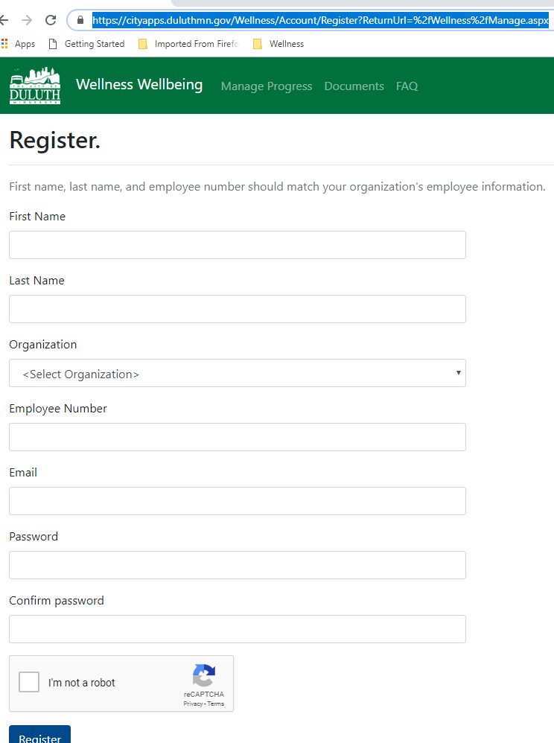
Step 5: Once you have registered as a new user, it is time to start entering your points! On the Log in (or home) page, enter your email and password and then click Log in: 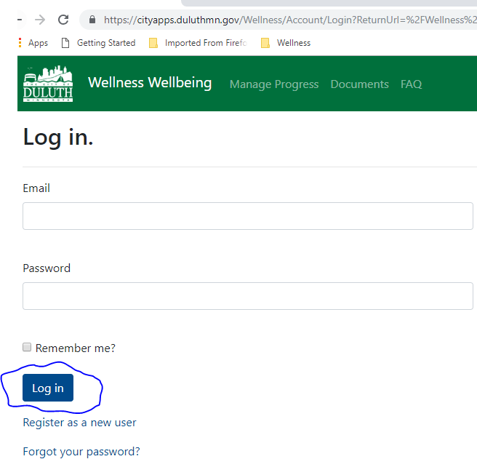
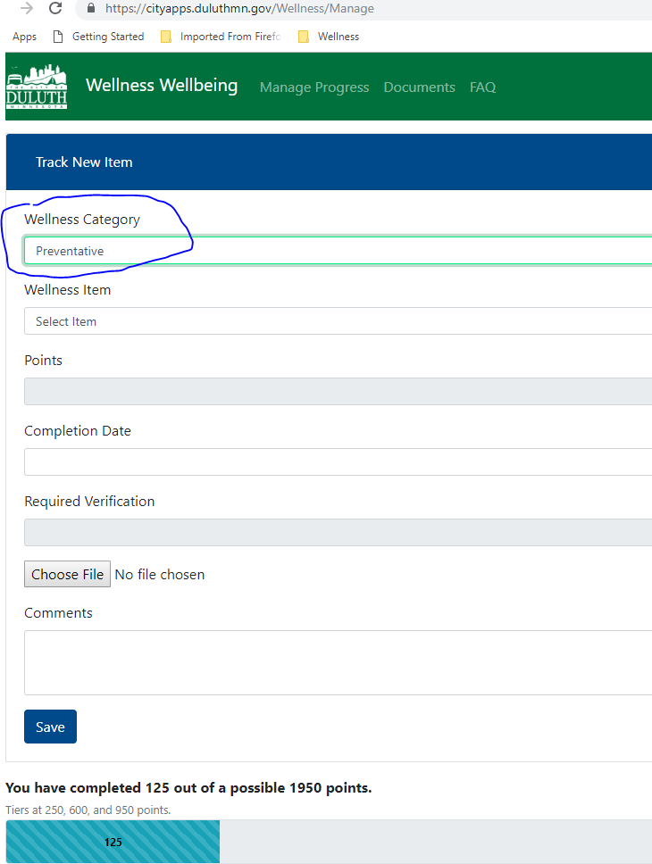
Step 6: Once you are logged in you will be able to enter your activities and upload the necessary documentation. Here you will select your “Wellness Category” by clicking on the drop-down arrow and select your category…below the example pictures Preventative:

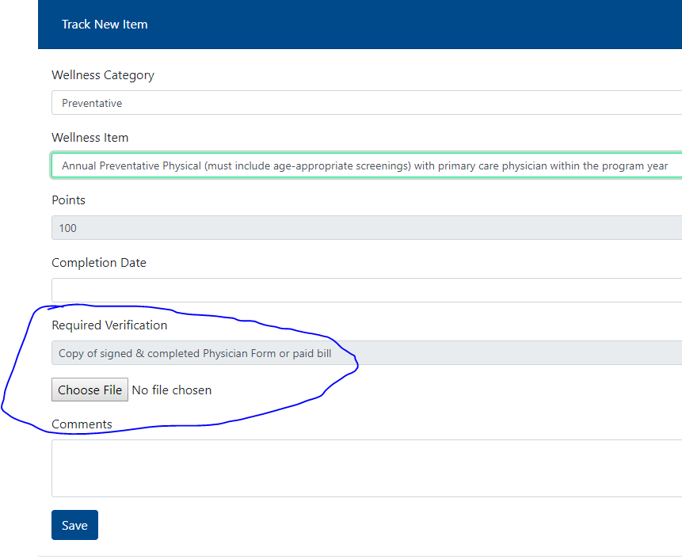
Step 7: Select the “Wellness Item” next, for example if it is your “Annual Preventative Screening” you will select that item and the points will automatically be displayed. You enter the “Completion Date”. You WILL need to upload the “required verification” document for this and some of the other Wellness Items.

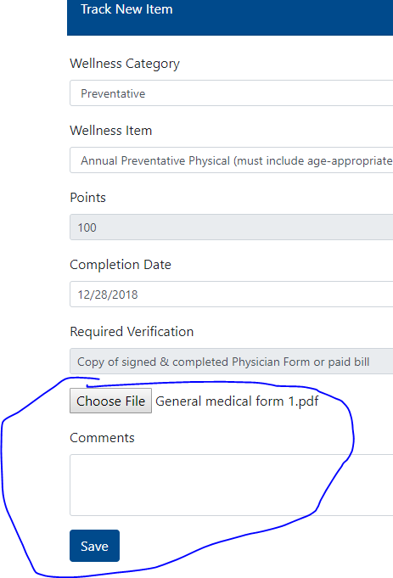
Step 8: Click on the “Choose File” button to upload the document you need to provide (if required), then click Save:

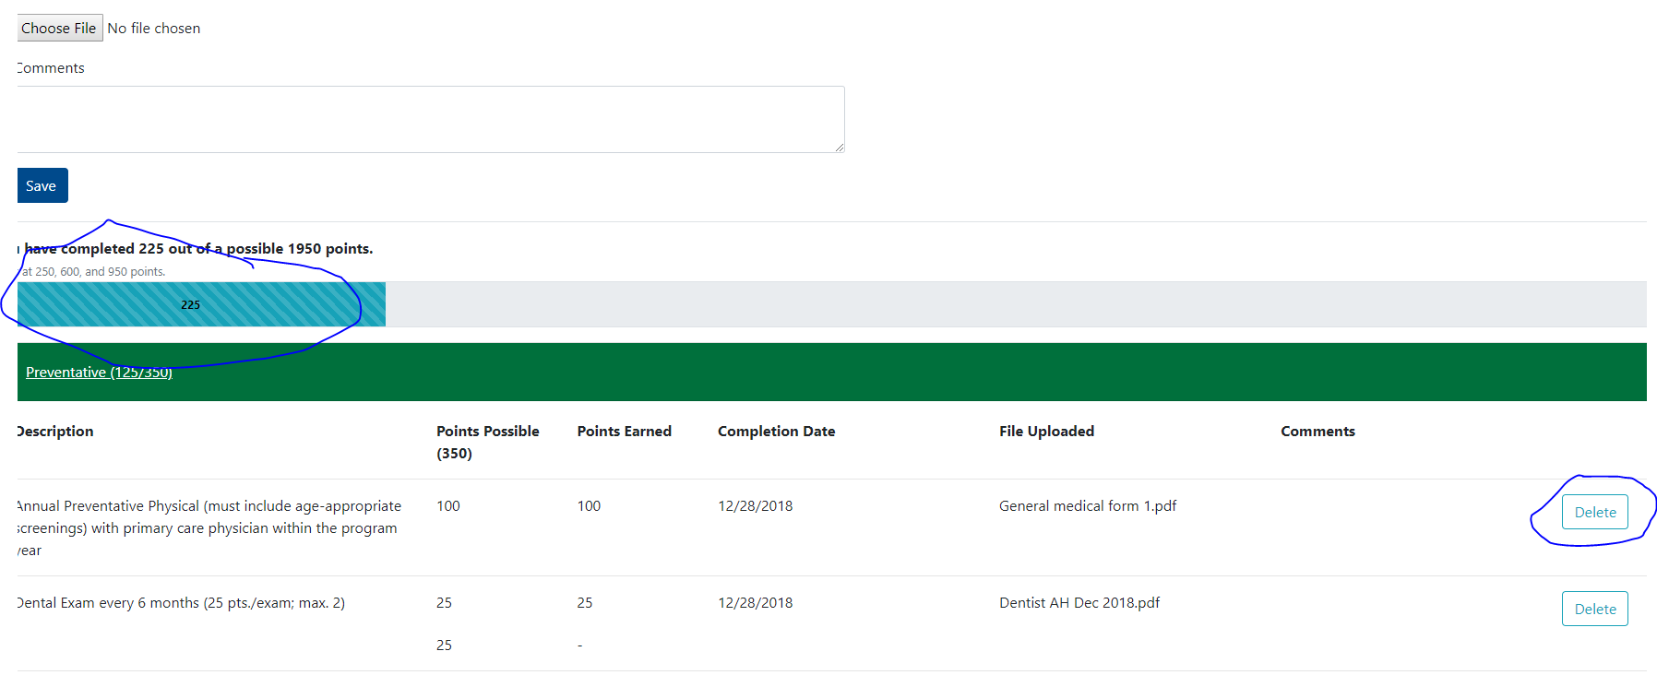
Step 9: Once you have clicked “Save” you will be able to see your progress on the “progress bar” and also be able to select the Wellness Category below to see what you have already added, and/or delete an item if you uploaded the wrong document:

Step 10: Continue to add your items as you go! You can log off when you are finished adding your item(s) and go back in to the Wellbeing site at any time. If you did not bookmark the site, you can always click on the “Register now” button on the Bridge and simply log in from there.

