

Mental health plays a huge role in your overall health and well-being. It affects everything, including how we think, feel and act, and helps determine how we make healthy choices and cope with stress.

Because it’s such a crucial component of your health, it’s important to focus on maintaining or improving your mental health. Here are five simple ways to do so every day:

1. **Express gratitude**.Taking five minutes a day to write down the things that you are grateful for has been proven to lower stress levels and can help you change your mindset from negative to positive.
2. **Get exercise**. You probably hear all the time how beneficial exercise is to your overall health, but it’s true. Exercising regularly can benefit your brain function, reduce anxiety and

improve your self-image.

1. **Spend time outdoors**. Getting outside, especially when it’s sunny, can greatly improve your mood, which in turn, benefits your mental health.
2. **Be kind**. Helping others and being kind not only helps the receiver of the act, but can also help you. It doesn’t have to be anything crazy—holding the door or giving a compliment can go a long way.
3. **Get a good night’s sleep.** Fatigued individuals typically experience drowsiness, mood changes, loss of energy and appetite, headaches, and a lack of motivation, concentration and alertness. Strive for seven to eight hours of sleep a night to improve your mental health.

5 Things You Can Do to Improve Your Daily Mental Health

Provided by City of Duluth JPE

**May 2019**

This article is intended for informational purposes only and is not intended to be exhaustive, nor should any discussion or opinions be construed as professional advice. Readers should contact a health professional for appropriate advice. © 2019 Zywave, Inc. All rights reserved.

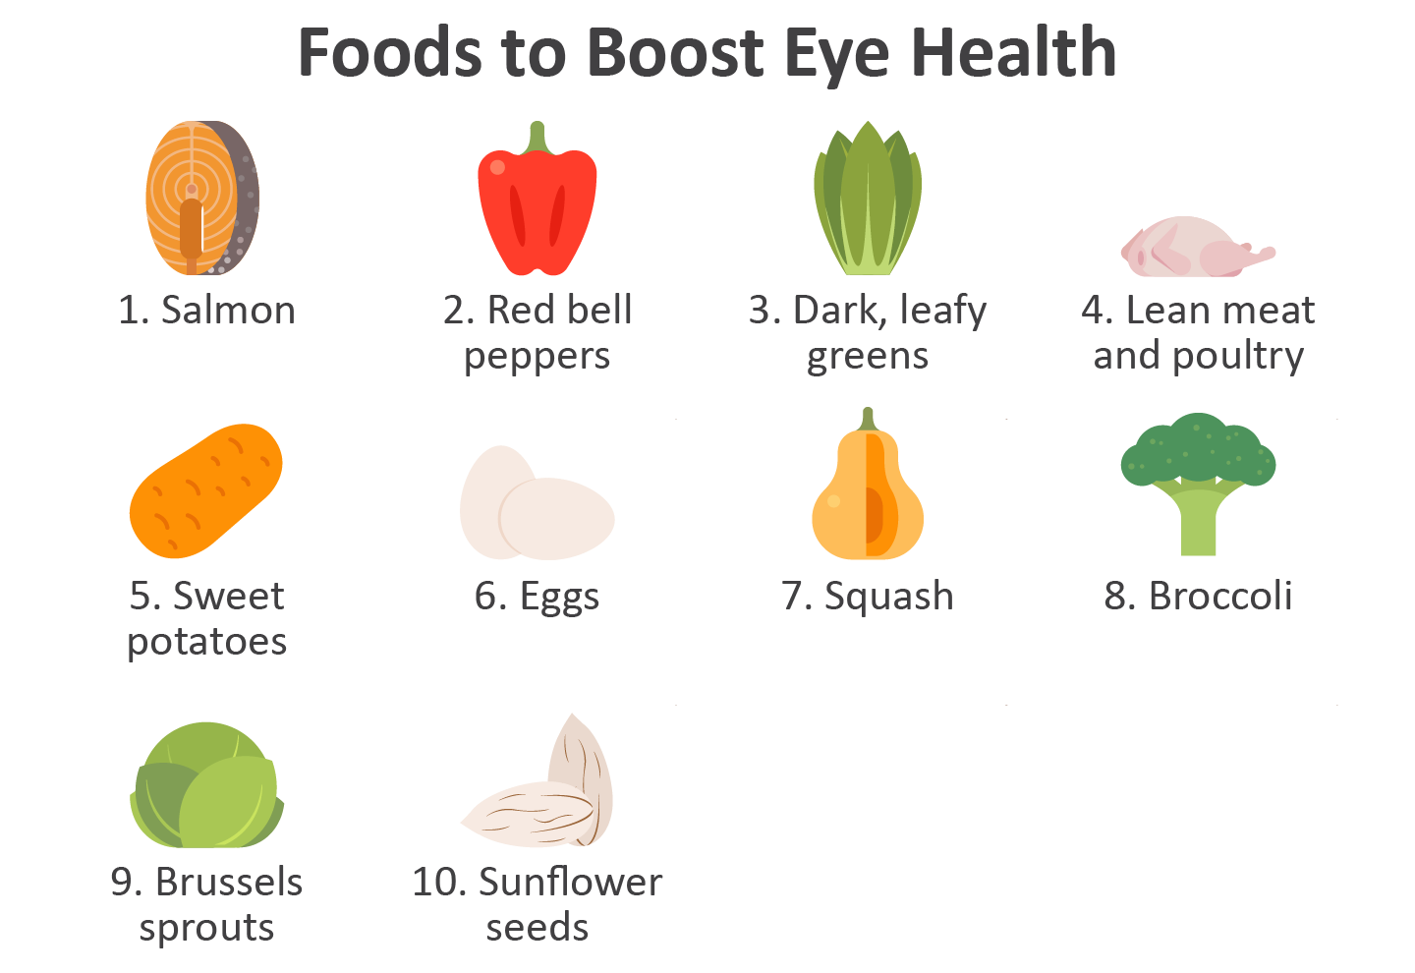

The Unexpected Ingredient in Your Oats

It’s not a superfood, and it’s not naturally occurring. It’s a pesticide. According to a report by the Environmental Working Group (EWG), almost three-quarters of the oat cereal, oatmeal, granola and oat bars contained traces of glyphosate.

**What’s glyphosate?**

Glyphosate is one of the most widely used herbicides in the world. It’s the main ingredient in hundreds of weed-killing pesticides.

**Are oats safe to eat?**

Federal officials report that the levels found in the oats is deemed to be “safe.” However, EWG claims that no level of exposure is safe, as glyphosate was classified as a probable carcinogen in 2015. To reduce your exposure, but still eat your oats, opt for organic oats.

Eye Health 101

Keeping your eyes healthy is a very important task. Fortunately, it’s also an easy thing to do. Here are five simple ways you can keep your eyes healthy:

1. Get a regular exam. Complete eye exams consist of a series of tests designed to evaluate your vision and check for eye diseases.
2. Wear protective eyewear. When you’re playing sports or doing a task that requires eyewear to be worn, heed the advice and wear glasses or goggles to prevent injury to your eyes.
3. Don’t smoke. Smoking can contribute to a host of irreversible eye diseases, so quit or refrain from smoking to protect your eyes.
4. Put your shades on. Wearing sunglasses protects your eyes from the sun’s harmful rays. Don’t forget to put them on when you’re outside!
5. Give your eyes a break. Staring at a computer screen for too long can cause a painful strain on your eyes. Whenever possible, try giving yourself a short break from looking at the screen.

**Cheesy Broccoli and Rice Squares**

1 cup low-fat cheddar cheese (shredded)

1 cup broccoli (chopped)

3 cups brown rice (cooked)

½ cup fresh parsley (chopped)

¼ cup onion (chopped)

½ tsp. salt

3 eggs (beaten)

1 ½ cups evaporated milk

1 tsp. Worcestershire sauce

Nonstick cooking spray

**Preparations**

1. Heat oven to 350 F and coat a 9-by-9-inch baking pan with nonstick cooking spray.
2. In a bowl, combine the brown rice, cheese, onion, broccoli, parsley and salt.
3. In a separate bowl, combine the eggs, Worcestershire sauce and evaporated milk. Pour over rice mixture. Mix well.
4. Pour into the baking dish.
5. Bake until just firm, about 35 to 40 minutes. Cut into squares to serve.

Makes: 8 servings

**Nutritional Information (per serving)**

|  |  |
| --- | --- |
| Total Calories | 183 |
| Total Fat | 4 g |
| Protein | 12 g |
| Carbohydrates | 24 g |
| Dietary Fiber | 2 g |
| Saturated Fat | 2 g |
| Sodium | 328 mg |
| Total Sugars | 6 g |

Source: USDA