

According to the American Heart Association (AHA), more than 1 in 3 women has a form of cardiovascular disease. And, heart disease is the leading cause of hospital stays for men in the United States. Due to the prevalence of the disease, the AHA recognizes each February as American Heart Month in hopes of raising awareness about the disease and how to prevent it.

Stress and Heart Health

While there are risk factors that contribute to heart disease that you can’t control, there are many things you can do to maintain your heart health. One of those things is to reduce your stress.

When stress is excessive, it can contribute to a host of health problems, including high blood pressure. If high blood pressure goes untreated, it can result in heart disease.

Reducing Your Stress

Taking steps to reduce your stress will improve your overall health. Try these tips:

* Plan and prioritize your most important responsibilities.
* Listen to relaxing music to help you calm down.
* Take time off from work to clear your mind.
* Exercise regularly to get your blood and endorphins flowing.

**When to Seek Help**

If the stresses in your life become more than you can bear or manage with these simple techniques, consider seeking professional assistance. A knowledgeable professional will be able to work with you to devise time management skills and stress-reducing techniques.

Looking to Improve Your Heart Health? Reduce Your Stress

Provided by City of Duluth JPE

**February 2019**

This article is intended for informational purposes only and is not intended to be exhaustive, nor should any discussion or opinions be construed as professional advice. Readers should contact a health professional for appropriate advice. © 2019 Zywave, Inc. All rights reserved.

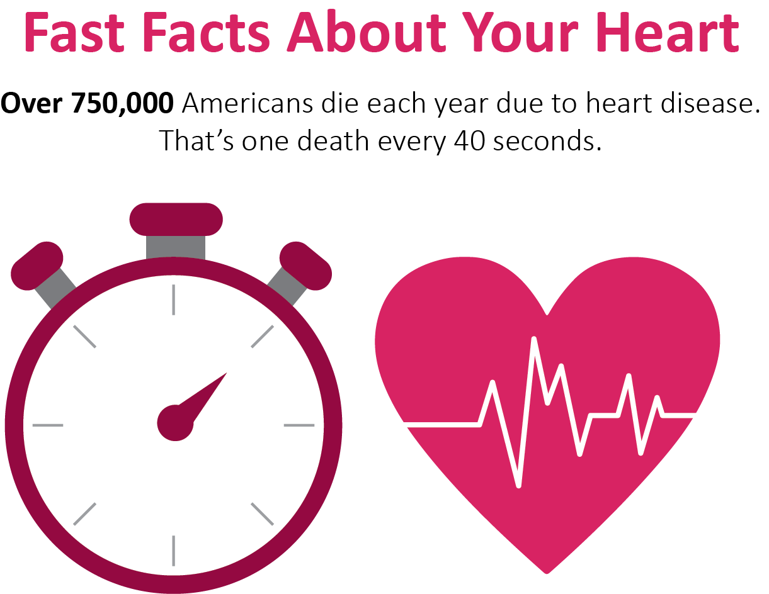

**2 Heart-healthy Indulgences You’re Sure to Be Excited About**

You may have heard whispers of dark chocolate and red wine being good for you and thought it’s too good to be true. Good news—the rumors are true. That’s right, there is some science behind the claims that these two indulgences can be good for your heart health.

According to researchers, red wine contains an antioxidant called resveratrol, which can help reduce inflammation and improve heart health. Dark chocolate contains a different antioxidant, called flavanol, which helps reduce blood pressure and improve heart health.

Now, this doesn’t mean you should go out and buy red wine and chocolate and splurge. Talk to your doctor to determine what enjoying these “in moderation” means for you.

Keep Your Heart Healthy Through Exercise

Did you know that exercising regularly could help you fight off chronic conditions and diseases? Exercise can help control your blood pressure, blood sugar and weight, raise your “good” cholesterol, and prevent diseases such as cancer, Type 2 diabetes and heart disease. According to the AHA, you should do these three exercises to improve your heart health:

1. **Aerobic activity**: Get at least 150 minutes of moderate-intensity aerobic activity (e.g., briskly walking) or 75 minutes of vigorous-intensity aerobic activity (e.g., running) every week.
2. **Muscle strengthening**: Incorporate muscle-strengthening exercises at least two days a week. For the purposes of general training, focus on two to three upper body and lower body exercises. Abdominal exercises are an important part of strength training as well.
3. **Flexibility training**: Flexibility training is important too, but it is frequently neglected, resulting in increased tightness as you age and become less active.

**Gingery Quinoa with Green Beans**

1 cup quinoa

1 ½ cups water or broth

2 cups green beans

2 ½ Tbsp. lemon juice

1 Tbsp. olive oil

1 Tbsp. sesame oil

2 Tbsp. soy sauce

¼ tsp. ground ginger

**Preparations**

1. Toast quinoa in a dry skillet over medium heat, stirring constantly for about 3 minutes.
2. Put quinoa in a medium pot and add water or broth.
3. Bring to a boil, then let simmer until all of the water is absorbed and quinoa is tender (10-20 minutes).
4. Set aside and leave uncovered to cool.
5. While quinoa is cooling, microwave the green beans until just tender.
6. Rinse in cold water to stop the cooking process.
7. In a large bowl, combine the quinoa, olive oil or cooking oil, sesame oil, green beans, lemon juice, soy sauce and ground ginger. Stir well.
8. Season with salt and pepper.
9. Serve at room temperature.

Makes: 6 servings

**Nutritional Information (per serving)**

|  |  |
| --- | --- |
| Total Calories | 239 |
| Total Fat | 9 g |
| Protein | 7 g |
| Carbohydrates | 33 g |
| Dietary Fiber | 6 g |
| Saturated Fat | 1 g |
| Sodium | 486 mg |
| Total Sugars | 2 g |

Source: USDA