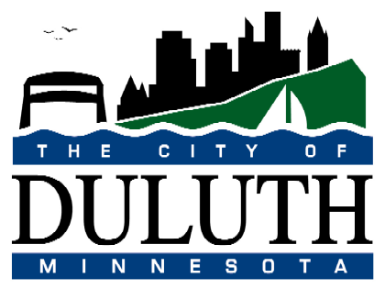
CITY OF DULUTH
PURCHASING DIVISION
Room 100 City Hall
411 West First Street
Duluth, Minnesota 55802-1199
218/730-5340 218/730-5922 FAX
purchasing@duluthmn.gov

Addendum #1
File #15-0122
Downtown Gas and Water Mains

This addendum serves to notify all bidders of the following question to the solicitation documents:

- Question: I found a 102 page document for this project. It states on Section 501, 503, 511 and 512 that cathodic protection is needed. There are no details for this. Do you know if they wish for us to a design or is there a design already? Do you have any documentation that shows it needs cathodic protection? Most Gas lines need them.

Response: The Downtown gas and water main project for the City of Duluth currently in the bidding phase is a plastic pipe project. The only cathodic protection on this project will be anode bags attached to water valves, hydrants, and some ductile fittings. The mechanical joint connections also will receive magnesium nut caps on the bolts. I am unfamiliar with the Section 500’s that is being referenced, and I’m assuming that where ever they were seen, they are not associated with the 1408 project.

So in summary, there are no cathodic protection design services needed.

Please acknowledge receipt of Addendum #1 by signing, dating, and submitting a copy with your bid/proposal. Thank you.

__________________________________ ______________________
^{Signature} ^{Date}

