**JAY STREET DEVELOPMENT QUESTIONS**

1. Can we be provided with the drawings and insight on the types of development layouts that the residence in the Lakeside area prefer?

**Answer: See next pages**

2. What constitutes a reference? Are you looking for just the name of the project and a contact person from that project? Or are you looking for an additional testimonial from that project as well

**Answer: Name of project, description of project, and contract person.**

3. If the houses that we plan to build for this project are pre-sold does that alter the completion date of Summer 2015?

**Answer: The houses either need to be built or presold, with a definite date of completion by Summer 2015**.

4. You mention you want 6 paper copies and  digital pdf file, would you like that pdf file on a jump drive? or emailed?

**Answer: It would be preferred to have the pdf file on a jump drive.**

5. So I understand correctly; is a development team considered a "single-purpose entity" (this is in regards to the 4th bullet point in Part 3)

**Answer: Yes, you are correct.**

6. When you mention that 3 of the houses have to be priced below $226,881; does this price include the house as well as the land and infrastructure? Or is that just for the house?

**Answer: The $226,881 is the price someone would have to pay to purchase the house to live in, so it would include the land and infrastructure to support a family living in the house.**

**Development Options that have had positive feedback:**

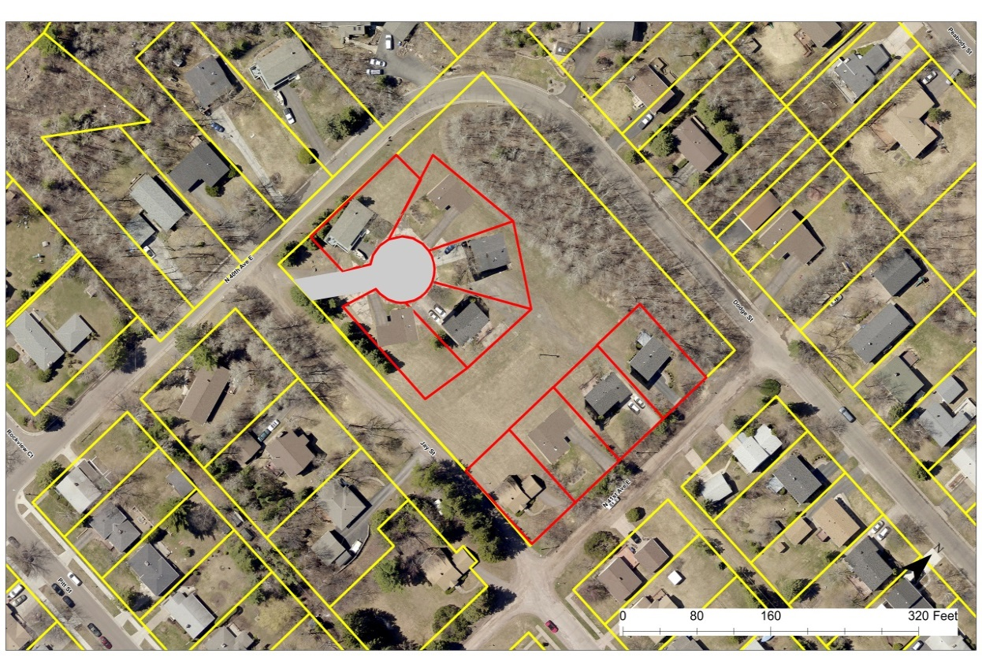

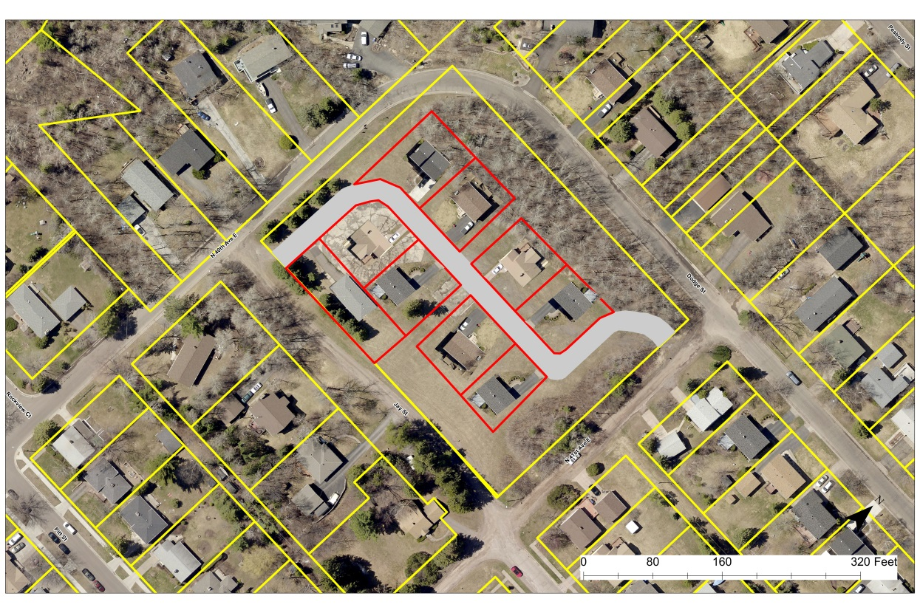

**Development Options that have received positive feedback:**

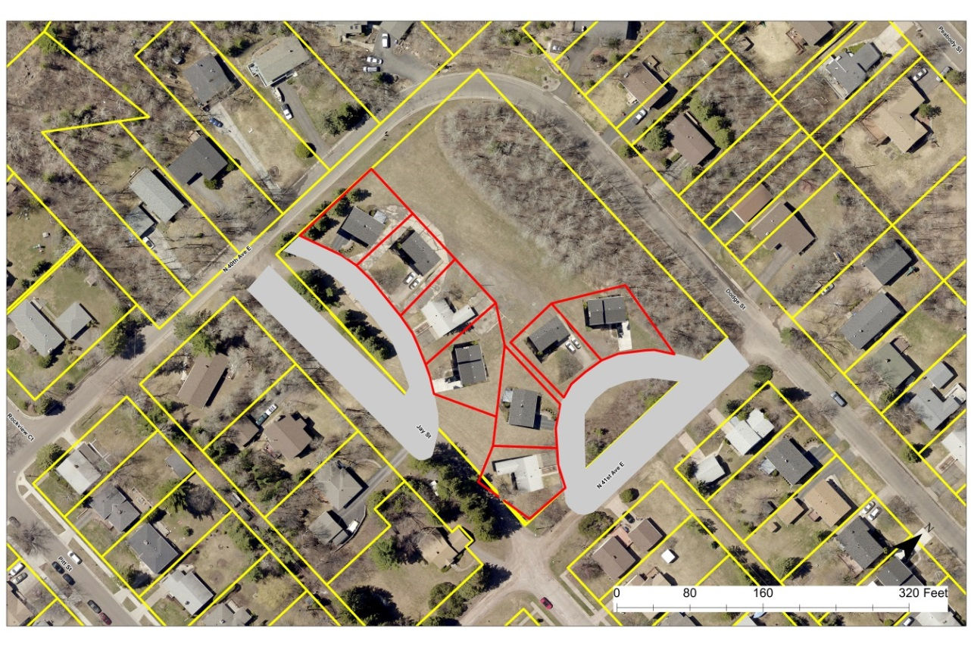

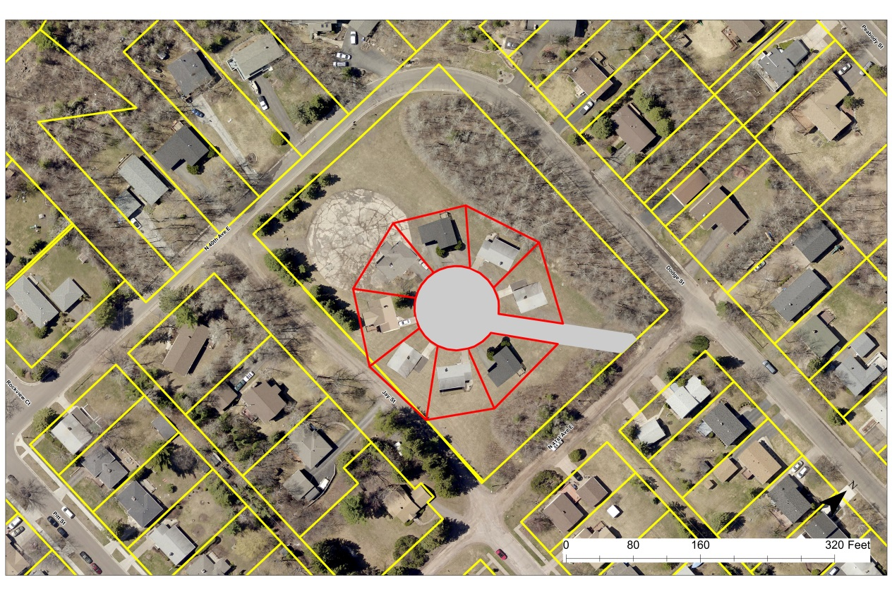

**Development Options that have received positive feedback:**

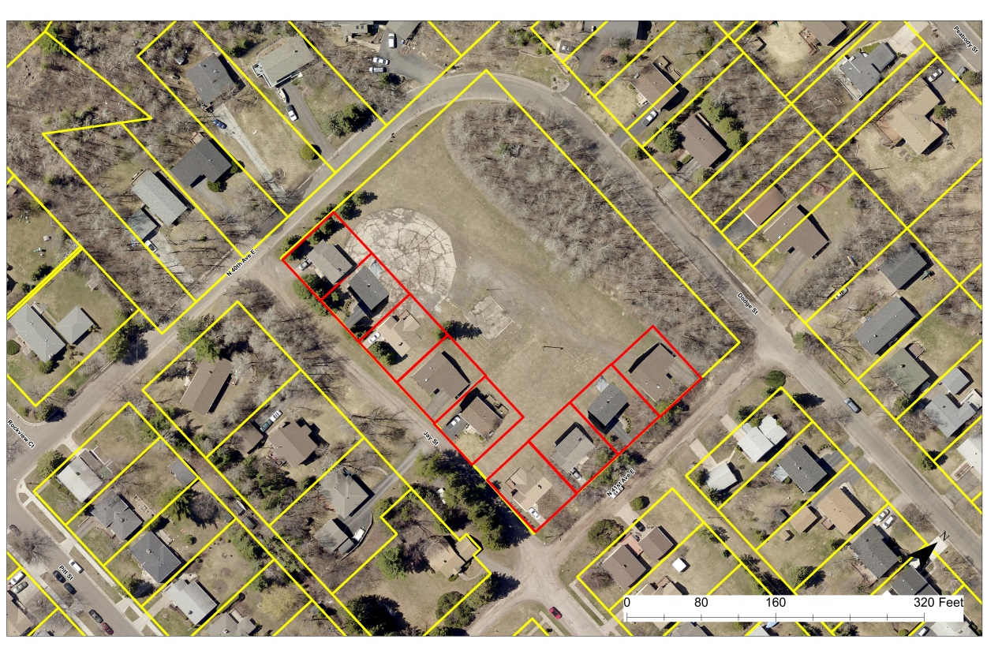

**Points of Interest expressed by Residents:**

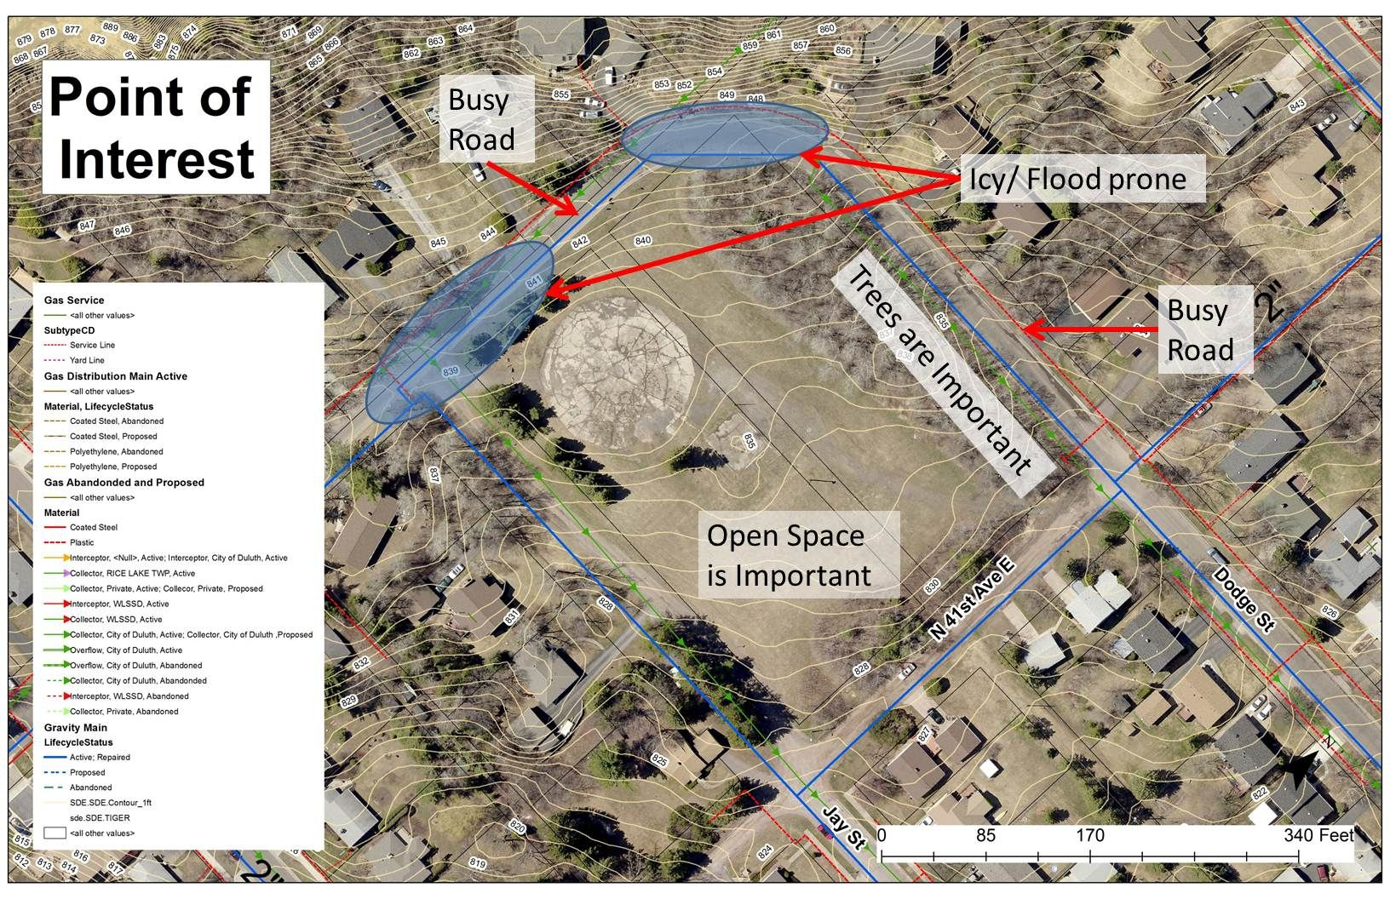

**Development Options NOT preferred by Residents:**

