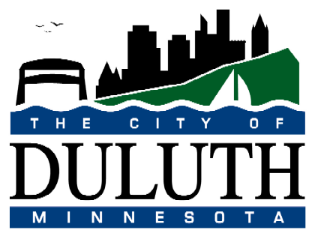
CITY OF DULUTH
PURCHASING DIVISION
Room 100 City Hall
411 West First Street
Duluth, Minnesota 55802-1199
218/730-5340 218/730-5922 FAX

July 31, 2026

REQUEST FOR QUALIFICATIONS
Public Art Strategic Plan

Please provide the City of Duluth with qualifications for Public Art Strategic Plan per the attached description, requirements and goals.

Please mark your Qualifications with the above title on the outside of the envelope and return to: City of Duluth, Purchasing, Room 100, 411 West 1st Street, Duluth, MN 55802 by 2 PM, Thursday, August 28, 2014.

All Qualifications will be acknowledged aloud in room 100 of City Hall. Proposals will be reviewed by committee according to established criteria.

The City of Duluth plans to select three final submissions and invite the three submitters in for a proposal and presentation.

Contact: Dennis Sears (218) 730-5003
Purchasing Agent
dsears@duluthmn.gov

Thank you.

