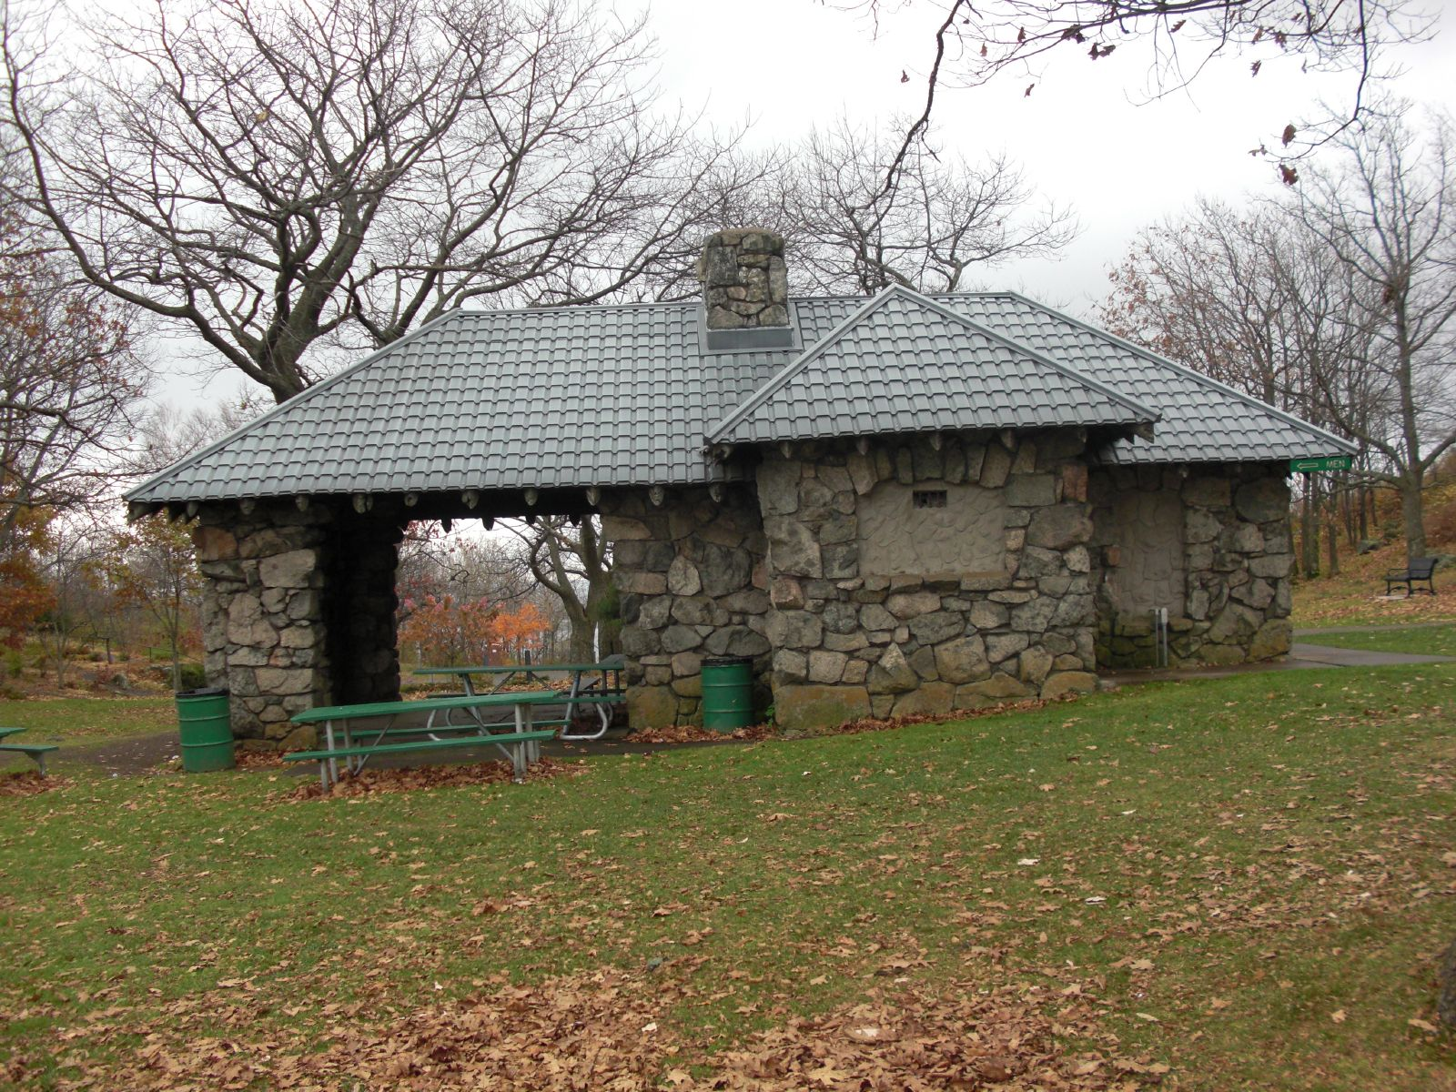
ENGER PARK SHELTER
IMPROVEMENTS AND ROTARY PEACE PLAZA PROJECT MANUAL

March 18, 2013

Project Number: 13-001
Bid Number: 13-001DS
Bid Opening Date: Tuesday, April 9, 2013 @ 2:00 p.m. CST

Owner: City of Duluth

Department of Public Administration
Architect Office
1532 West Michigan Street
Duluth, Minnesota 55806
(218)730-4434

Architect: Collaborative Design Group
100 Portland Ave South, Suite #100
Minneapolis, MN 55401
(612)332-3654

