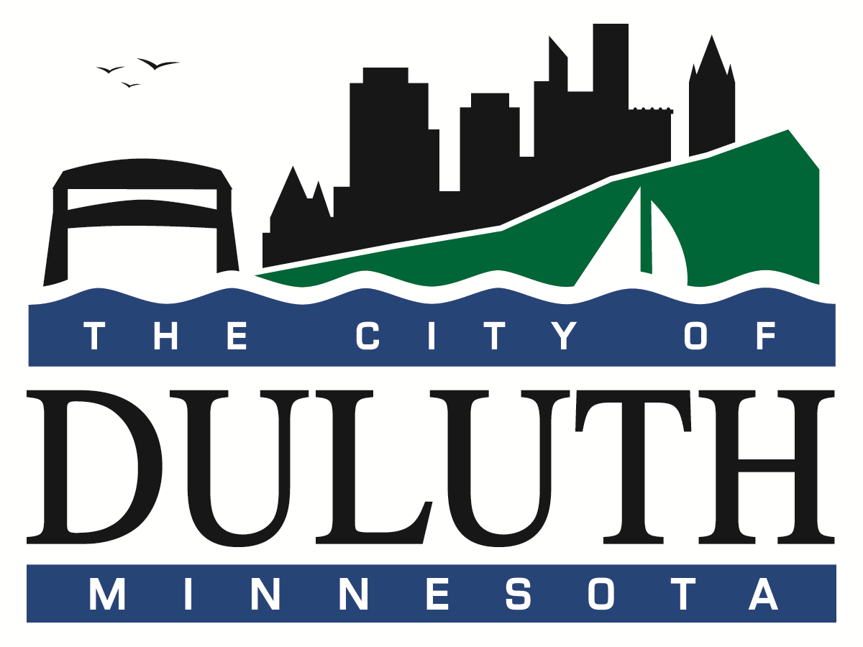 Economic Development Strategy Plan Process

Economic Development Plan
Vision: Strategic
Decision-Making Tool Framework
Long-term Guide Policy Aligned With City Priorities

Economic Realities:
Trends
Markets
Growth
Competition
Basic Industry
Emerging
Industries

Inputs/Data:
Real Estate
Labor Force
Transportation
Education Capital
Utilities
Land Use
Natural Resources
Suppliers

Goal/Objective:
Create a strategic decision-making tool that helps guide development priorities for the City of Duluth. The Plan will include strategies to leverage public investment to attract private investment supporting sustainable growth and prosperity. The Economic Development Plan will be aligned with other city priorities including the Mayor's 90x20 initiative, the Prosperity Agenda and the Comprehensive Land Use Plan, and provide a clear set of guiding principles for responsible development.

Outcomes:
- Present a job strategy that leverages local resources and workforce
- Focus on Family-sustaining jobs and wealth creation
- Encourage a sustainable and robust economy that supports current and future industries
- Support a well-trained, qualified workforce
- Provide flexible policies and tools to meet current and future needs
- Create a framework for ongoing strategy updates

Guiding Principles
The City of Duluth will engage and involve key partners in the city's vision for future growth and development. We will encourage responsible growth that aligns with Administration's priorities including:
- Seeking, retaining, and attracting talent to meet the objectives of the 90x20 initiative,
- Promoting the objectives of the Mayor's Prosperity Agenda,
- Implementing sustainable practices,
- Investing locally, and
- Seeking growth that is consistent with future land use priorities and needs.

