Kraus-Anderson Construction Company, FTP Access

The purpose of this document is to provide instruction to clients of Kraus-Anderson Construction Company in obtaining access to our FTP site. Our FTP site is a secured location requiring a username and password.

- Using “My Computer”, visit our ftp site by entering the following into the address bar: ftp://ftp.krausanderson.com

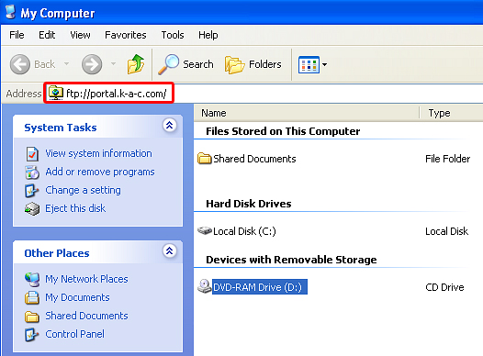
ftp://ftp.krausanderson.com

- You will be prompted for a login, your login information is as follows:

  - Username: spiritmtnbp2
  - Password: spiritmtnbp2

- You will be able to read, execute and browse everything you see once logged in. You will be unable to write or delete files/folders.
- For questions relating to content found on this site, please contact the Project Assistant or Project Manager at Kraus-Anderson assigned to assist you:

  - Project Manager: Terry Thompson
  - Project Assistant: Deb Coffman

- For technical issues using this site, please contact the IT Department at Kraus-Anderson:

  - IT Department Contact: 612-336-6400

