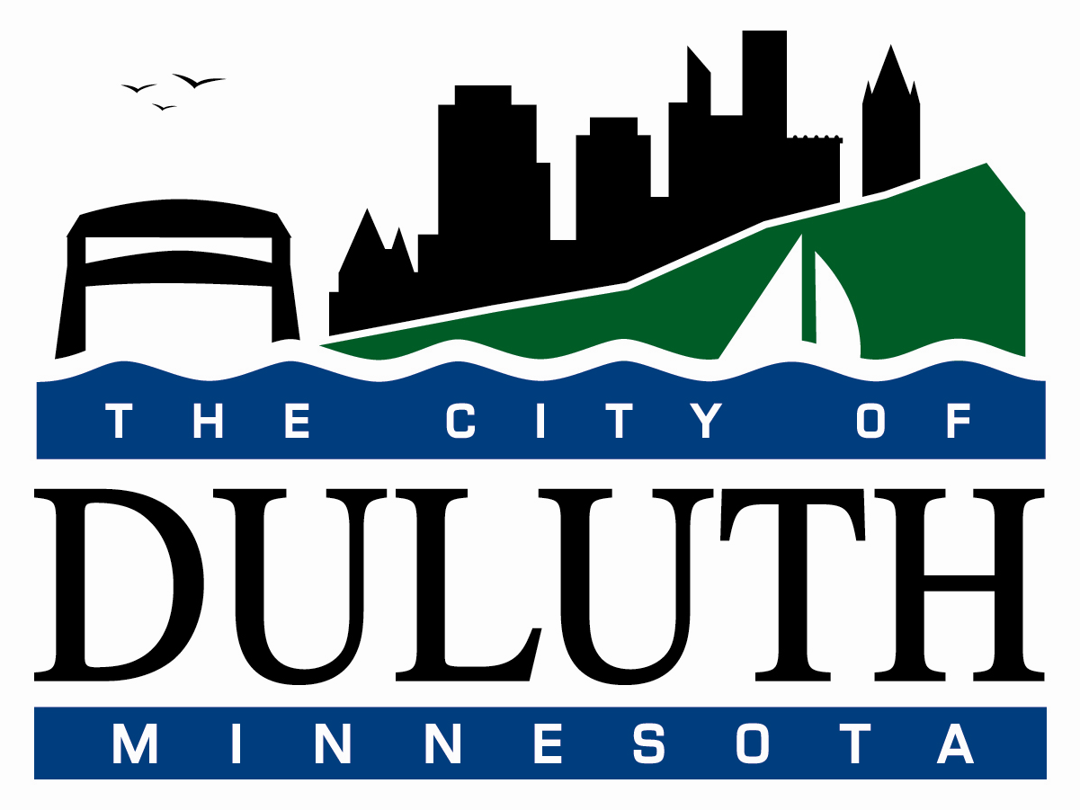

July 31, 2026

ADDENDUM #1
REQUEST FOR QUALIFICATIONS
10-37DS
Historic Building Design Services

Please note that Monday, November 8, 2010, from 8:00AM to 11:00AM representatives of the Duluth Economic Development Authority will be at the NorShor Theatre to answer questions and provide a tour of the facility. All parties interested in touring the facility should be there at that time.

