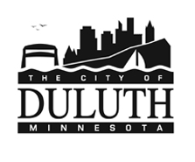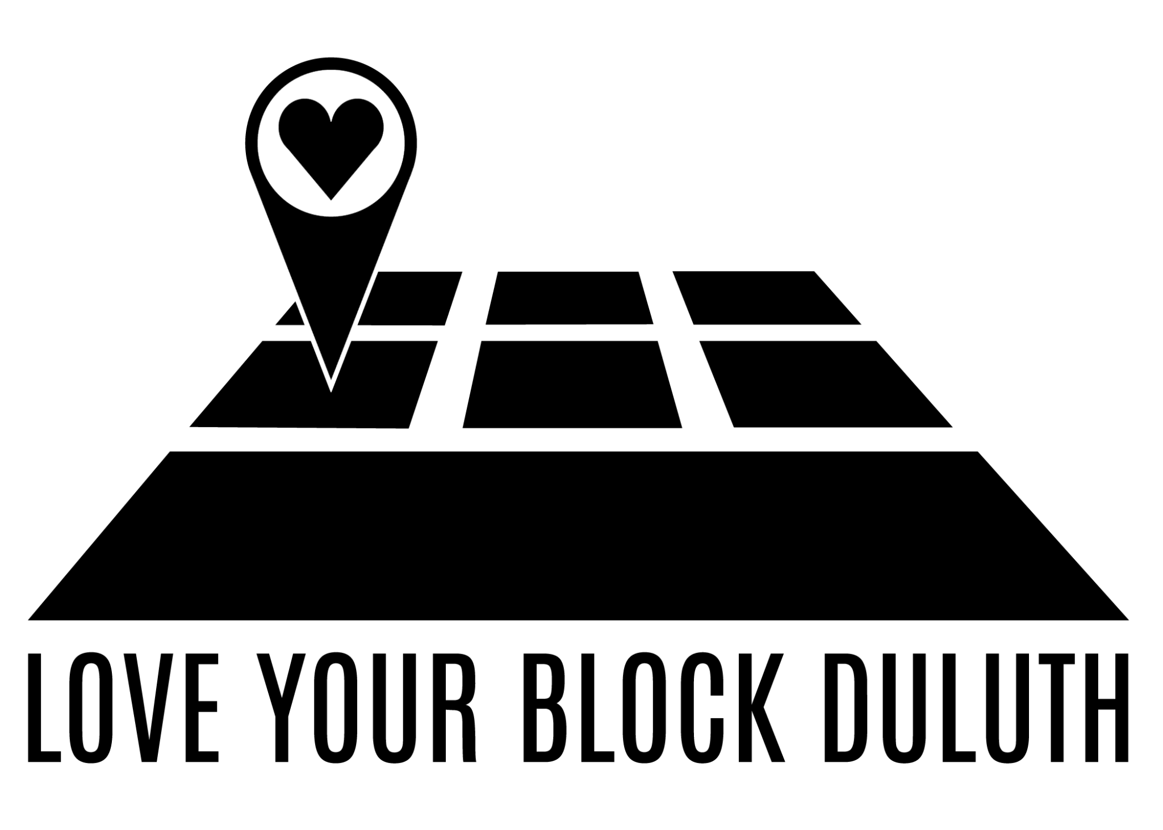

2023 Love Your Block - Community Caretaking Grants
It takes all of us to care for the spaces in our neighborhoods. We feel better when we know the people around us and feel proud of where we live. YOU can make that happen.

Residents are invited to submit their idea to care for and connect with the people on their block and receive up to $500 to make it happen. In 2023, bring your neighbors together to host a clean-up (trash and/or abandoned waste), trim overgrown plants, paint a porch, or gather around a campfire in conversation.

Approximately 20 events across Lincoln Park and Central Hillside will be funded. Events must take place between June 12 - September 15, 2023. Money can be used to pay for a dumpster, food (no alcohol), and other needed supplies.

Please email completed application, photos, and property permissions by June 1, 2023 to
Love Your Block at serickson@duluthmn.gov, text at 218-348-2165, mail or in-person to 615 W 1st St, Duluth, MN, 55802.

Project Leader (name, email, phone):

As the project leader, I agree to:
- Submit before, during, and after photos of any funded project.
- Document and share the measurements of success (e.g. pounds of garbage removed, volunteers engaged) with the LYB team.
- Arrange an in-person check-in with LYB staff following the grant award. .
- Include people from the neighborhood in the project or event.
- Communicate with LYB staff if project plans, leader, or resource needs change.
Sign or initial here to agree to above: _______________
- Project location (must be in Central Hillside or Lincoln Park)

- Private or public property? Who owns this property?

- Do you have permission to make changes to the site? (Written permission from the property owner must be attached to this application.)

- Insert, attach, or text 5-10 current photos of the event or project site.

- What do you plan to do?

- What impact will this have on your neighborhood? How will you include people in your neighborhood?

- How will you know your event or project is a success?

- Please provide a budget that includes all planned and/or estimated expenses for the event or project described above. (Add additional sheets as needed)
Item/Service | Purpose | Vendor | Quantity | Cost per | Total Cost
Ex. 10 foot dumpster | Dispose of collected garbage | Twin Ports Trailer Trash | 1 | $250 | $250
PROJECT TOTAL
LOVE YOUR BLOCK GRANT REQUEST (up to $500)
OTHER DONATIONS OR GRANTS CONFIRMED
MINNESOTA DATA PRACTICES ACT—TENNESSEN WARNING
The City of Duluth is asking that you provide information on the Love Your Block Duluth application form to determine your eligibility and suitability for a grant award.
In accordance with the Minnesota Government Data Practices Act (Minnesota Statutes Chapter 13), the City of Duluth is required to inform you of your rights regarding private data collected from you. We will use your private data only when it is required for the administration and management of the program. Persons or agencies with whom this information may be shared include:
- City of Duluth employees and other persons involved in program administration.
- Auditors who perform required audits of this program.
- Authorized personnel from the other local, state, and federal agencies providing funding assistance for your grant.
- Those persons who you authorize to see it.
- Law enforcement personnel in the case of suspected fraud or other enforcement authorities as required.
The City of Duluth cannot release private data to anyone else or use the private data in any way unless you give the City of Duluth permission by completing a consent form. Please note, however, that data must be released if required by court order. Supplying the information on the application is voluntary. However, a refusal to supply the information requested will mean you will not be considered for the program.
Love Your Block Data Consent Form
All applications are reviewed by the grant review committee without identifying personal information per the policy above. If your project is selected for funding, the Love Your Block team and the City of Duluth will want to share this exciting news with partners and the public.

Please indicate below if and how you would like the Love Your Block team to share information about the project leader and/or organization applicant.

I, the project leader/grant applicant, give consent for Love Your Block and the City of Duluth to share with the public in the form of a press release or other communications in the following ways. Please check all that apply.
- Project leader’s full name
- Project leader’s first name only
- Name of organization associated with the application
- Please do not share any of my or my organization’s identifying information with the public.
Initial here to confirm consent as indicated above: ______________

