City of Duluth Emerald Ash Borer Management Plan

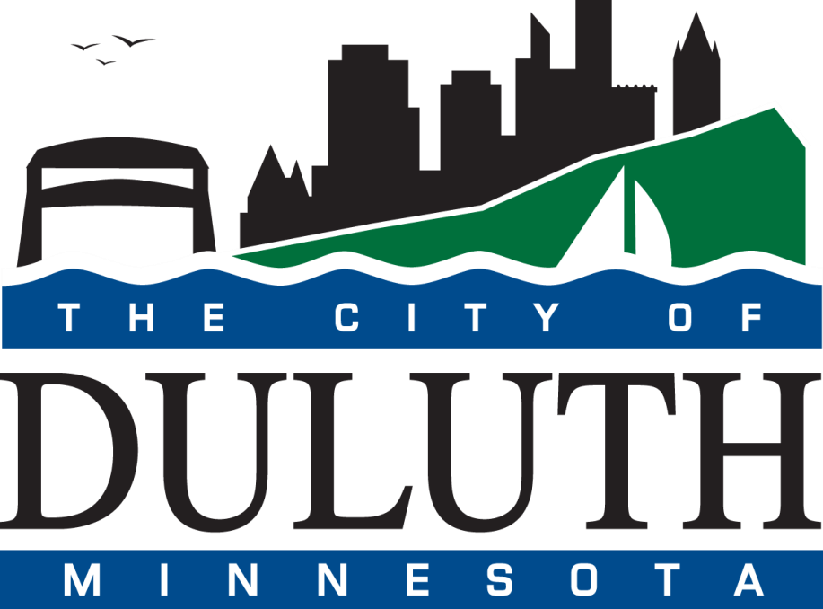

November 2016
Originated July 2015

Revisions Proposed November 2022
Table of Contents
Introduction 4
Overview of Emerald Ash Borer 5
Life cycle 5
Tree Inventory Summary 6
Proposed Management Plan 7
Administration 8
Monitoring and Inspection 8
Insecticide Use 8
Community Outreach 10
Ash Tree Removal 10
Ash Wood Disposal 12
Reforestation and Canopy Replacement 13
Biological Control 13
U.S. EAB Distribution Map 15
November 1, 2016 15
January 4, 2021 15

Introduction
Emerald ash borer, or EAB, is a non-native beetle that feeds on and causes widespread mortality in all native species of ash (genus Fraxinus). The insect bores into the tree, eating the phloem tissue, the innermost layer of bark, and disrupts the transportation of nutrients and water. If left alone, EAB can kill an ash tree in 2 to 7 years, depending on age, size, and initial tree vigor.
EAB was first found in the United States in 2002 near Detroit, MI. Its presence in Minnesota was first detected in Ramsey County on May 13, 2009. As of November 1, 2016, it has spread to 30 states and the Canadian provinces of Ontario and Quebec, decimating ash tree populations wherever it becomes established.

EAB was confirmed in St. Louis County in Duluth, MN in October 2015. An earlier infestation was confirmed in Douglas County, in Superior, WI in 2013. Once EAB has been detected within 10-15 miles of a non-infested area, all ash trees within the 15 miles are at risk of infestation.
Now that EAB has been detected in Duluth, the City of Duluth developed and will implement this city-wide EAB management plan.

EAB detection methods are improving and researchers continue to learn more about EAB weaknesses. An effective EAB management plan will spread out the costs of selective tree removal and pesticide application over time, while the science catches up.

According to the Minnesota Department of Agriculture, Minnesota has the highest volume of ash trees in the U.S. with almost a billion forestland and urban ash trees. Duluth has about 2,404 boulevard ash trees alone, not including park or privately owned ash. Because trees have many direct and indirect benefits, the impacts of losing such a large population of trees in an urban area are important to consider when managing the pest. Trees allow for reduced electricity use for air conditioning in summer as they shade homes and businesses. The reduced energy use consequently lowers emissions from power plants. Trees also directly contribute to reductions in atmospheric CO2, through respiration and sequestration of carbon in their leaves and stems, as well as reductions in airborne particulate pollution. Another benefit of trees in the urban landscape is the reduction of storm water runoff through rainfall interception. Indirect benefits of urban trees to humans include reduced incidence of cardiovascular disease and asthma, faster recovery from surgery, increased physical activity, and increases in property values within communities.

EAB populations increase exponentially over time and, accordingly, a proactive plan will ensure selective ash tree protection, preserving the trees’ economic and environmental benefits as well as supporting public safety through a combination of monitoring, insecticide treatment, structured removals, sanitation, canopy replacement, community outreach and the possible use of biological control agents. By defining and beginning an integrated pest management strategy now, the City will lessen disruption to the urban forest, stretch the management costs associated with EAB over a longer period of time, and create an atmosphere of EAB awareness to detect additional infestations as early as possible.

Overview of Emerald Ash Borer
Emerald Ash Borer (EAB), Agrilus planipennis Fairmaire, is an extremely destructive tree-killing flatheaded boring beetle. This insect is a non-native species from China that likely arrived in the United States as larvae living in wooden shipping pallets. The beetle was first discovered in the
U.S. in Michigan, in 2002. In the forests near the site of initial infestation in southeast Michigan, over 99% of the ash trees with stems larger than 2.5 cm in diameter died. The invasive pest has spread and is now devastating the ash tree genus throughout the eastern half of the United States, with mortality in the tens of millions. These insects can quickly decimate ash populations in an infested area, which poses a significant loss of tree benefits to communities as well as the high financial burden of treating or removing trees for municipalities and property owners.

Adult EAB are defoliators, but the damage caused by the adults feeding on leaves is not what causes mortality. Tree decline caused by EAB happens in the larval stage. After initial infestation, EAB populations increase throughout the tree. As populations increase in the tree, more larvae are feeding on the phloem, girdling the tree. The loss of the phloem layer prevents the transportation of vital nutrients throughout the tree. Research estimates symptoms of decline occur after about 5 years of infestation, making early visual detection difficult. Once canopy dieback occurs, trees typically die within 2-4 years. Green ash (Fraxinus pennsylvanica) has proven to be the most susceptible species to EAB attack and is also the most heavily planted ash species throughout Duluth. The beetle will attack stressed trees as well as healthy, vigorous trees, while most native wood boring beetles are attracted only to trees under stress.

The borer has been shown to endure winter temperatures as low as -30°F, though only a small percentage of larvae survive such cold events. This may be good news for parts of northern Minnesota as it is not unheard of to experience temperatures below -30°F, which could cause mortality in EAB populations. The City of Duluth is not so lucky due to its proximity to Lake Superior. According to www.usclimatedata.com, average low temperatures in Duluth in the coldest months sit above zero; 7°F in December, 2°F in January, and 6°F in February.

Life Cycle

From mid-June through August, adult female EAB beetles will deposit eggs on the trunk and major branches of ash trees. After the larvae hatch, they tunnel through the bark to the cambial region just under the bark. Larvae begin feeding on the phloem tissue for several weeks. The phloem tissue is part of the tree’s vascular system where sugars and nutrients are conducted throughout the tree, making a great meal for the larvae. As the larvae feed, they leave S-shaped galleries under the bark. Most larvae are full grown by September and overwinter in a pupation cell in the bark of the ash. Larvae that have not reached maturity by the time winter comes may feed for another summer before reaching adulthood. This biennial life cycle typically occurs only in healthy ash trees with low larval densities. In April or May the following year, the larvae in the pupation cells will fully pupate. After about two weeks, the adult beetles will emerge from the bark, leaving the D-shaped exits holes associated with flat-headed borers. Emergence starts in May and peaks in July. The beetles are active during the day, feeding on leaves in the ash canopy. About a week after emergence, adult beetles begin to mate. Females begin laying individual eggs on the bark surface of ash shortly after mating. The average female will oviposit about 55 eggs but has potential to lay more than 150 eggs.

Tree Inventory Summary

A nearly complete inventory of the city has been completed as of August, 2021. This includes boulevard (2018) and park (2021) trees. Included are 1,407 ash trees or 11.6% of the street and park tree population. Based on these numbers and removals done by the city and contractors the initial inventory underestimated the ash population by 600-1,000 trees.

(This paragraph is included for continuity between the original plan and this revision.) Between 2010 and 2013, an inventory and assessment survey was conducted of the entire boulevard tree population to track and manage individual urban trees. The survey was conducted by Green Corps members and volunteers. The survey reported 2,404 ash trees out of a total 11,485 trees, or 21% of the population. Of all the ash, the most prominent species found throughout the city is green ash, which is also the most susceptible to EAB attack. The variables of interest in this boulevard survey were diameter of tree trunk at breast height (DBH) (DBH = 4.5ft from the ground), whether or not the tree needs maintenance, maintenance priority, sidewalk damage from roots, power wire conflict, trunk condition and crown condition.

Table 1: Duluth’s ash size class distribution based on diameter at breast height. Data from inventory two inventories (2010-2013 and 2018 to present).

Proposed Management Plan

When EAB was first found in Minnesota, it was believed that the state would eventually lose all ash trees. Due to advances in treatment options, early detection and management, and potentially successful biocontrol, EAB may spread differently in Minnesota than it has in the states that were initially infested. It has been detected relatively early making it possible to slow ash tree mortality through integrated pest management strategies. So far, the percent of infested counties over time is much lower than the national average for infested states (see Graph 1). Duluth’s management approach will involve a combination of monitoring, structured removal of ash trees, systemic insecticide injection treatments, and the possibility of biological control. Slowing the spread of EAB and ash tree mortality enables the City to stretch management costs over a longer time period and allows for the retention of some of the more mature, high-quality ash trees and canopy cover.

Graph 1: Percent of Minnesota counties infested with EAB as of 10/10/16 verses percent national average of counties infested over time, prepared by the Minnesota Department of Agriculture.
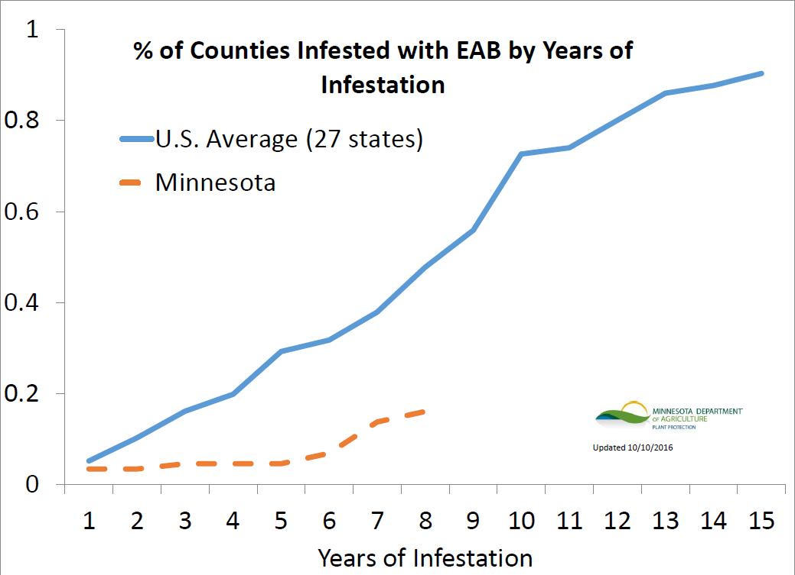

Administration

The Supervisor of the City of Duluth’s Park Maintenance Department will be responsible for implementing this plan and will monitor grant opportunities and apply for grants when appropriate to help fund this management plan.

Monitoring and Inspection

City staff need to be key players in detection. Parks and public works crew members should undergo EAB training so they can monitor the ash trees in the areas where they work.
Additionally, EAB training should be provided for all employees interested in learning about the insect and its threat. The University of Minnesota holds annual Forest Pest First Detector workshops throughout the state, including one at the Cloquet Forestry Center. Anyone with a background in tree or forest health is encouraged to become a Forest Pest First Detector.

City residents are often concerned about their private own trees and are encouraged to report any suspicion of EAB infestation. Residents should report to the city. If EAB is suspected in a county not confirmed as infested, the report should be made to the MN Department of Agriculture (MDA) who will ask for a photo and send someone out to inspect the ash tree in question. If an infestation is suspected in an area under quarantine but not known in that exact location, residents should still report it to the MDA, as the MDA is mapping all known infestation in Minnesota.

Implementation of an annual EAB inspection program to detect infections as early as possible is essential for immediate management of the pest.

- Purple prism traps are in place throughout the city and is an ongoing project organized by the USDA and MDA as a means of early detection. Purple traps are used during the summer to capture adult EAB beetles and are monitored by the MDA.
- Branch sampling is the process of pulling back the bark of ash trees to monitor for larval galleries. This inspection technique is best done during fall or winter months. Branch sampling conducted in 2015 by the MDA in Park Point Park revealed the presence of the Emerald Ash Borer in 4 ash trees on Duluth’s Park Point.
- Visual inspection includes monitoring for crown dieback, decline and thinning, epicormic sprouts (suckers) on limbs or trunk, vertical splits in bark, D-shaped adult emergence holes, or excessive woodpecker activity. These signs are usually apparent only after heavy infestation.

Insecticide Use

One aspect of the integrated pest management strategy for EAB is the preventative treatment of ash trees with insecticides. There are multiple formulations of emamectin benzoate that are available for EAB injections. Emamectin benzoate has been shown to be more effective than alternative insecticides, such as imidacloprid. Trees that are determined to be healthy and mature enough by the City Forester may be treated.

Of the 2,404 boulevard ash trees in the City of Duluth, 911 ash trees were identified as are candidates for injection. Candidacy is based on a given tree’s DBH and location within the City. Because larger trees provide more community benefits and take longer to replace, only mature trees over 12” DBH will be eligible for treatment by the city as finances allow (except as noted below in the Ash Tree Removal section, where an exemption is warranted). Areas with high concentrations of large ash trees will be the focus of these treatments. Of those approximate 911 ash trees, about 20% will be annual candidates for injection. Insecticide use began in July 2015 in Gary New Duluth. If EAB is confirmed in or near other neighborhoods, these areas will become priorities for injection as financial resources allow. During the spring and summer of 2015, 176 boulevard ash trees were treated. Tree injections will continue throughout Duluth in support of EAB best management practices.

The insecticide will be administered to the tree’s vascular system via trunk injection. It is not applied to bark, leaves or soil. Emamectin benzoate is not a one-time chemical treatment; in order to be effective, the tree needs to be reinjected every three years. Animals and insects that crawl or land on the tree, but do not feed on the tissue, will not be affected by the insecticide. Emamectin benzoate has been shown to affect a broad range of plant-feeding insects. However, ash trees that are not treated will likely be killed by EAB, and this will also negatively impact the insects associated with ash trees.

Emamectin benzoate is not a neonicotinoid, a type of pesticide that has been proven to be harmful to honey bees. As it is, ash trees are wind pollinated and not a source of nectar for bees. Because emamectin benzoate is administered exclusively through trunk injections, there is no concern about adjacent trees or plants absorbing the insecticide through the soil.

Evidence shows that woodpeckers that feed on larvae under the bark of ash trees are not likely at risk of being poisoned by the trunk injections. Woodpeckers do not tend to feed on larval cadavers and insecticides are less toxic to birds than to insects.

As additional infestations are detected, some trees will be beyond treatment. Various sources have suggested that if a given ash tree has at least 70 percent of its canopy intact it may be a candidate for insecticide use. However, trees with less than 70 percent of their canopy intact are unlikely to recover from EAB infestations even if treated with a highly effective systemic insecticide like emamectin benzoate.

The literature shows injection treatment costs can be lower than removal costs when compared as an annual cost. The efficacy of treatment depends on several factors, primarily the extent of the infestation, but other limiting factors such as the availability of funding for chemicals, and personnel time which are not related to the tree’s condition, influence whether a tree will receive treatment. As treatment options continue to evolve, costs of treatment will likely change. It is important to stay up to date on these options and management recommendations. Insecticide use is a worthwhile EAB strategy, especially for large trees that contribute a significant amount to the community.

The advantage of the insecticide treatment program is that in treating select ash trees, the city will continue to derive the many environmental and social benefits of large canopy shade trees while reforestation efforts take hold. Although concerns exist over use of pesticides, arguably, an equal environmental impact exists for the potential benefits lost that are provided by large canopy shade trees.

The city will encourage property owners to carefully evaluate environmental impacts before using pesticides to treat EAB on private property. Owners who decide to use EAB pesticides are urged to use trunk injection rather than soil drenching, which will help reduce pesticide drift and reduce impacts to groundwater and surface water. Pesticide tree injection/applications must be done by a MDA certified pesticide applicator.

As of November 2016, Certified Pesticide Applicators in Duluth providing EAB injection treatment include, but are not limited to:

- Levy Tree Care – (218) 393-4847
- Ricks Tree and Stump Removal – (218) 728-2427

Community Outreach

Adult beetles have been reported to travel about a ½ a mile from the tree they emerge from. Because EAB does not travel very far on its own, it is important for the public to be aware that the spread of this pest is primarily anthropocentric, which means that many infestations are started when people move infested ash nursery trees, logs, or firewood into un-infested areas.

Keeping residents informed on the status of EAB, and encouraging involvement plays a key role in managing the pest. The City and the Natural Resources Commission will provide community members with the resources to learn how to identify EAB on their land and highlight the importance of restricted movement of hardwood ash materials. Interested citizens are encouraged to participate in the annual Minnesota Forest Pest First Detector course. This course is available at the Cloquet Forestry Center in Cloquet, MN annually.

The MDA and the MNDNR have community outreach in place to discourage movement of firewood throughout the state. Residents are informed via signage and pamphlets of the importance of slowing the spread of EAB and other invasive species. MN Statute 89.551 discourages the spread of forest insect pests and restricts movement of unapproved firewood on MN DNR state land. Violators are subject to penalties and fines.

Ash Tree Removal

Prompt removal and sanitation of trees on public property that are infested is recommended. Based on the degree of infestation and health, ash trees must be removed to limit hazardous conditions (large falling branches) and minimize the public safety risk associated with dead and declining trees. Recent research has shown that dead ash trees are extremely dry and brittle and require removal within a 12 to 18-month period after death to avoid the risk of structural failure.

The City plans an aggressive structured removal plan. Structured removal is the proactive, systematic removal and replacement of non-infested ash trees in a planned or “structured” approach. The removal of non-infested ash trees, and trees in declining health, reduces the overall number of ash trees that will have to be dealt with while spreading out the available time, cost and resources to implement the plan. The vast majority of structured removal will take place on boulevard trees, as they will pose the highest safety risk once infested. The program will focus on declining ash trees (>30% dieback in the canopy). , Additional considerations for trees selected for removal are as follows: trees with general health problems, structural defects, storm damage, poor structural form, those growing beneath utility lines, and all ash under 12” in DBH.

The City Forester may, at his or her discretion, exempt from removal individual ash trees. Exempt trees will require injection treatment with emamectin benzoate or other insecticides as approved by the City. Injections will be recurring and are to be done every three years. Valid grounds for exemption of a tree include, but are not necessarily limited to:
- The tree is healthy, well-formed, and vigorous;
- The tree is located at a site where the pace of tree growth has been and will likely continue to be unusually slow;
- The tree is in a densely developed, sparsely vegetated urban area where the incremental aesthetic, health, and ecological value of a single mature tree is arguably elevated; and/or
- The tree is located at a site where the ash tree in the ground is likely to fare better than a newly planted tree of a different species.

Persons or private entities have the option to request an exemption for boulevard trees in front of their residence.
Persons or private entities have the option to treat ash trees in the public right-of-way at their own expense with the approval of, and at the discretion of, the City. Treatment must be with an injection system, not a soil drench or drip-line drench and must be administered by a licensed tree care specialist. The City reserves the right to remove any treated municipal tree.

The current ash population is 21% of the urban trees in Duluth. The goal is to treat 37% of the ash throughout the city. This requires the removal of about 1,500 ash trees from the boulevards.

Under the structured removal plan, all trees under a DBH of 12” will be removed (except as exempted, see above). According to Cliff Sadof with the Department of Entomology at Purdue University, smaller trees have less ecological and social value than larger trees, but grow exponentially faster than larger trees. Thus replacing young at-risk ash with non-ash trees that will quickly restore the canopy is more economical. When removing a tree under 12” DBH, its value can be replaced in 13 to 14 years. Realizing the value of a tree with 18” DBH would take over 40 years. Preserving small ash would be expensive and return less value than a larger tree. Therefore, preservation is a better option for larger trees, and reasonable efforts should be focused on preserving these larger, healthy trees.

Typically, infestation centers are not detected for 3‐5 years after insects arrive due to the subtle nature of initial signs in the tree. When an infested tree is identified, surrounding trees will need to be surveyed to determine the extent of infestation and the number of trees that will need to be removed. The city should consult with the MDA and the USDA to make an official determination of infestation.

After infestation is confirmed, City Staff will mark the ash prior to removal. They will hang EAB information cards on the doors of nearby resident’s homes. Residents will have the option of treating boulevard trees at their own expense per the procedures outlined above. After trees are marked, the resident will have 30 days to respond before trees are removed. A record of trees being treated by homeowners will be kept by the Park Maintenance Department to ensure the city does not accidentally remove citizen treated ash.

The removal of dead ash trees in parks and open spaces is done on a risk management basis. Dead trees in parks and open spaces that are adjacent to public areas will be the first to be removed. Ash trees far away from human activity will be left to fall on their own.

The City will not require the removal of ash trees on private property unless an ash is a hazard to the public. In the event a private ash becomes a hazard to the public, the property owner will be notified by the Park Maintenance Department and be given notice that the tree must be removed.

Trees removed from boulevards and parks have economic value. If infested wood is to be utilized it must be processed before it can be used as lumber. See the ash wood disposal section below for more information.

Ash Wood Disposal

As of September 13, 2016, SE St. Louis County has been placed under an EAB quarantine. The quarantined area runs from MN Highway 33/US Highway 53 on the west to the Lake County
border on the east. The northern border of the quarantine runs from US Highway 53 along Three Lakes Road (County Highway 49) east to the intersection of Vermilion Trail. It then continues along the northern edge of Gnesen, North Star, and Alden townships. This extends south to the Carlton County/State of Wisconsin border.

Subsequently, the movement of ash wood waste with bark and sapwood intact, green lumber, ash nursery stock, and all hardwood firewood is regulated by the MDA. Movement from a quarantined area to a non-quarantined area is prohibited within the State of Minnesota.
Frequently asked questions regarding the quarantine and a map of the current quarantined areas can be found at https://mnag.maps.arcgis.com/apps/webappviewer/index.html?id=63ebb977e2924d27b9ef0787ecedf6e9

Due to the previous Park Point-only quarantine, a secured collection and staging area has been established on Park Property at the end of Park Point. This site was available for City of Duluth Staff, Park Point residents and Tree Contractors working on Park Point to dispose of ash trees, limbs and wood chips. Now that the entire city is under the quarantine, additional collection areas may be established in other neighborhoods as the need arises.

After all bark including ½ inch of sapwood is removed from ash, the wood can be used for lumber. This lumber could be used for park projects including mulching, constructing benches, playground equipment, etc. If ash mulch is to be used, the chips must be chipped at no greater than 1” X 1” in two dimensions.

Reforestation and Canopy Replacement

Reforestation with a variety of tree species is the primary objective to manage and retain Duluth’s urban forest. Green ash was one of three or four species heavily emphasized by Midwest communities, including Duluth, to replace the American elms lost to Dutch elm disease. Ash was chosen because of its tolerance of a range of environmental conditions and resistance to other pests. The choice to replace elm with ash resulted in yet another large monoculture. At the time, species diversity was not a well understood concept as a means to manage unforeseen devastation to plant communities. Learning from the mistakes made in the past, the city will avoid monocultures through diversity and mixed planting schemes. Species diversity will reduce the impact of devastating tree loss events caused by biological factors.

The Parks Maintenance Department will dedicate the spring and fall to replanting the ash trees removed according to this plan. The reforestation goal is to plant one tree for every ash tree removed.

As part of the replanting plan, the city will have a 2-year aftercare program for planted trees. Stressed trees are more susceptible to diseases and insect pests. It is essential to water regularly and prune properly to maintain tree vigor and form. The Park Maintenance Department will be responsible for new tree aftercare.

Biological Control

As part of the integrated pest management strategy, the City of Duluth will explore the possibility of using biological control agents. Biological control agents are natural enemies of pests that reduce their populations. Biocontrol requires an active human role, such as release into the environment, unlike natural controls which occur naturally and require no human involvement.

EAB in its native range is not a significant threat, accept on ash trees that are stressed or already in decline, or ornamental ash trees from North America planted in China. This natural resistance in Asian ash is due in part to EAB’s natural control agents found in China. Several species of parasitic wasps have been identified to control EAB. Four species have been approved, so far, for release in the United Studies, Oobius agrili, Spathius agrili, Tetrastichus planipennisi, and Spathius galinae. These wasps, in their native range parasitize anywhere from 50-90% of EAB larvae or eggs, which is an effective control method. If the parasitoids can become established in the U.S. they might be a significant contributor to successful EAB management.

Duluth must have a forested area with 15 – 40 acres or more of infestation for the USDA and affiliates to release parasitoid wasps. The wasps must have an area this size to establish a sustainable population. The possibility of release will only arise if city forest, outside residential areas, becomes heavily infested.

Biological control has shown some success in the southern part of the state where infestation has been detected. The status of biological control agent establishment has yet to be tested in the northern part of the state.

U.S. EAB Distribution Map

November 1, 2016
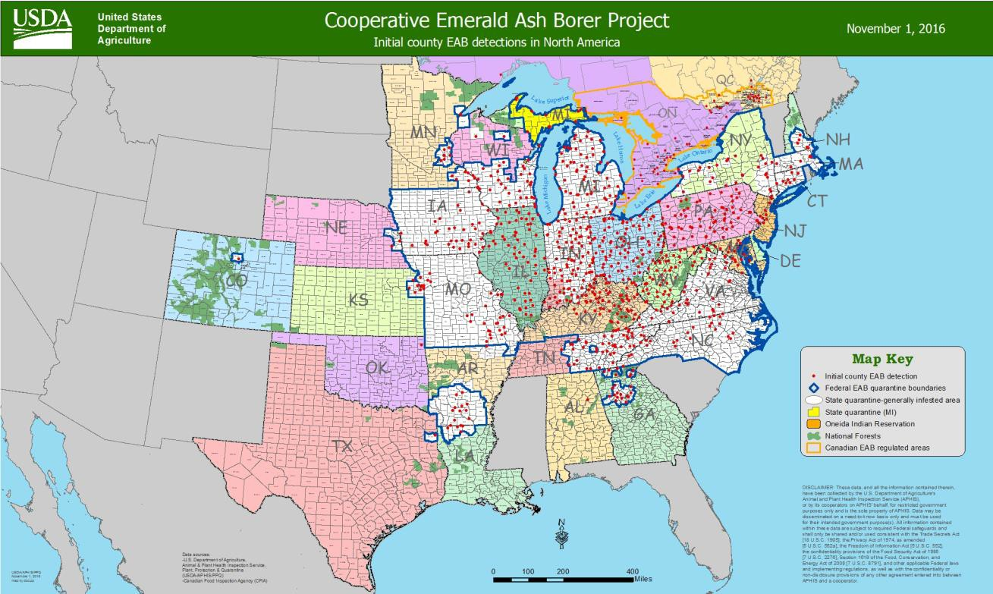

January 4, 2021
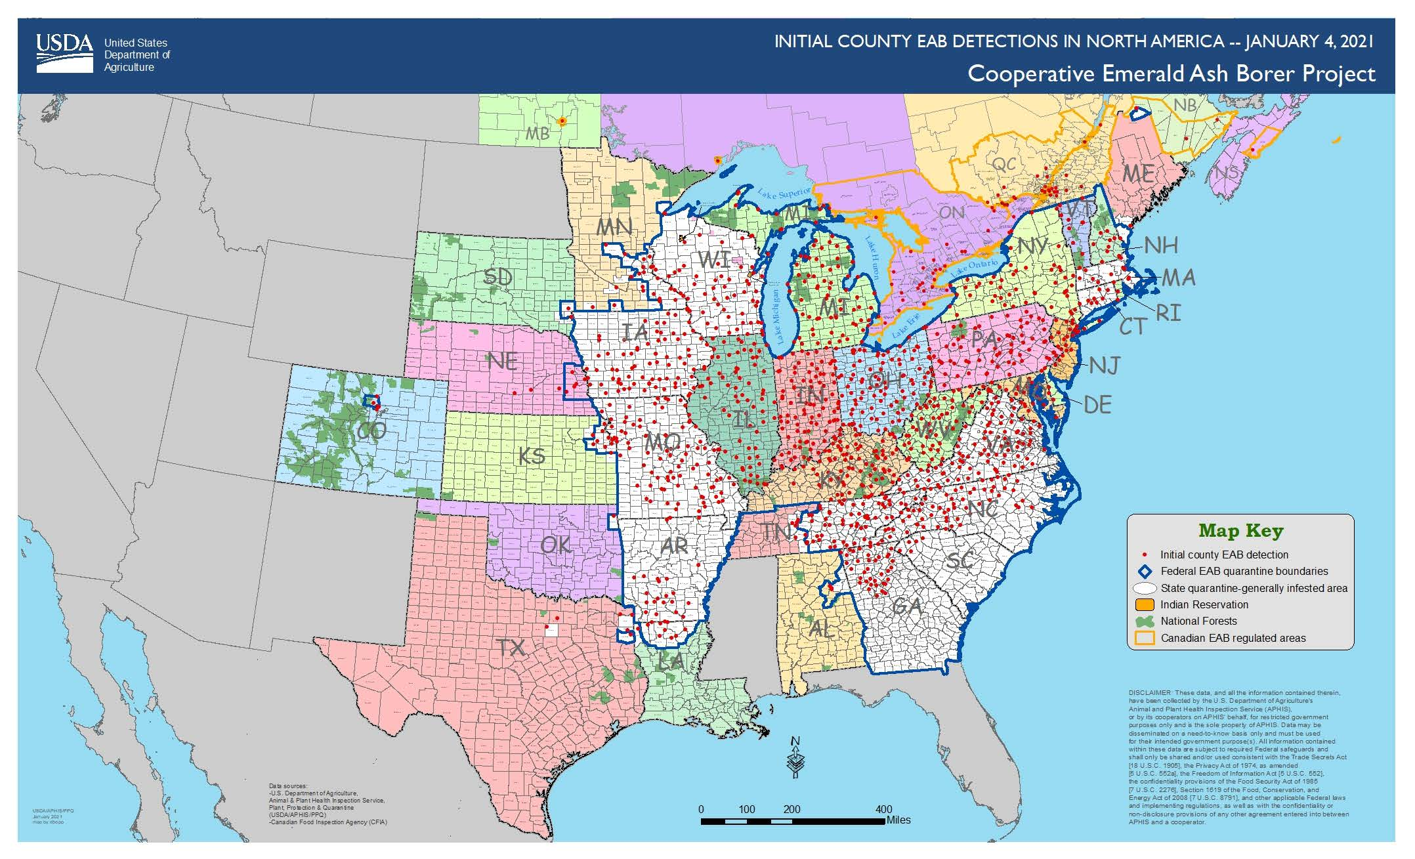

This plan outlines best practices to mitigate and reduce the impacts of EAB infestation in Duluth. For more information on EAB, please refer to http://www.emeraldashborer.info/. The information on this site is peer-reviewed and approved prior to being added to the site and is highly reliable.

