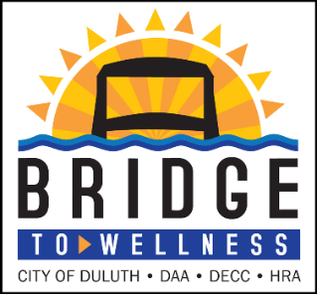
September Wellness Action Message

Quarterly Theme: Building Blocks for Sustainable Change
September: The Importance of a Wellness Goal & Being
Your Best Self

The Importance of Writing a Wellness Goal
Writing things down makes them real and sends a signal to your brain that you're serious about making them happen and what steps you need to take. Writing down a wellness goal brings these valuable benefits:
- Stronger neural pathways
- Brings more clarity
- There’s a brain-to-hand connection
- Moves you forward and creates a roadmap
- Helps you create a vision in your MIND of how you want to be in the future
Participants are 42% more likely to achieve your goals just by writing them down!

Simple Steps to Get Started

Step One: Visualize your Best-Self
Ask yourself, what does my best self- look like to me?
- What healthy choices am I making or not making?
- Am I happy with my food choices and meal preparations?
- Am I happy with how I connect with others?
- How am I feeling today?
- Am I making a difference to others?
- Is there a skill I want to learn?

Step Two: Setting a Wellbeing Goal
Start with making your goal REAL:
Write a R.E.A.L. version of your goal and determine how you will reward yourself for completing it. Post this form somewhere you will see it every day and track your daily progress. Review what you learned in the process and celebrate your success!

My R.E.A.L. (Realistic, Easy, Attainable, Life Goal) goal is:
_____________________________________________________________________________

Bridge To Wellness – My Health Rewards by Medica

Employees participating in the Bridge to Wellness well-being program can earn additional points through My Health Rewards by Medica.® My Health Rewards is an online points-based program that helps you take small steps to reach your health goals. You’ll earn points for completing activities and get rewarded on your own personal path to health. This program is available for employees who are actively enrolled in the Duluth Joint Powers Enterprise active and pre-65 health insurance plan administered by Medica.

Throughout the year, My Health Rewards by Medica provides nudges and resources to help you be your best self, based on the wellbeing path you set for yourself. Remember that change doesn’t happen overnight and it’s okay to make adjustments along the way. Allow yourself to enjoy the journey toward your healthiest self — one small step at a time.
